**Candle Community Trust**

**Project Worker – Young Person and Family Support**

Candle Community Trust welcomes applications for the Project Worker position. This position is in collaboration with TUSLA and works specifically with young people who are known to the Child and Family Agency and referred to Candle Community Trust. This exciting role will work with young people, their parents/guardians and families referred to the Candle Service on a 1:1 basis. The role will support engagement and participation through home visits, individual support, advocacy and developmental programming with both the young person and their family. The role is also supported by and works with the diverse range of services within the Candle centre.

**If you are passionate about working with young people and their families this could be the role for you.**

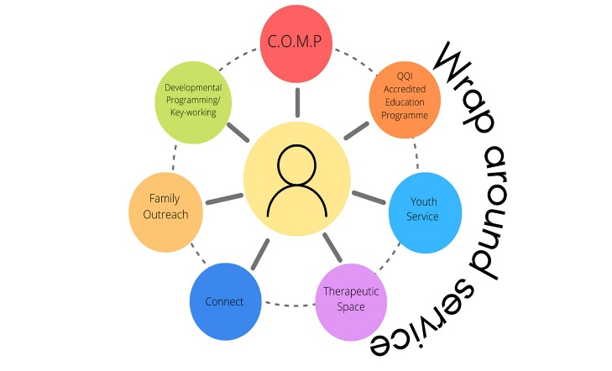At Candle young people are at the heart of everything we do, their voice and their needs are central in the planning of services and we believe that young people can reach their full potential when provided with the right opportunities. At Candle we offer a wide range of services including a full time Training Programme, Connect project, Youth Service, Therapeutic Space, Family Outreach, Developmental Programming, Keyworking, Outreach Mentoring Programme. Each young person can access any of the services offered in Candle as part of our wraparound approach.

Candle is a progressive organisation that has pioneered the integration of the Trauma Recovery Model, Restorative Practices, and an Empowerment Model in our approach to working with young people and their families. Staff are fully trained in trauma informed practice and our key methodologies and the organisation commits to the professional development of staff through ongoing training and development opportunities.

The work base for this role is at the Candle Campus, Ballyfermot.

**Role Description**

The Project Worker (Young Person and Family Support) position is a role within the Developmental Services Programme in Candle Community Trust. The role will work specifically with young people, their parents/guardians and family to support participation and engagement on a 1:1 basis. This dynamic role will provide services through home visits, individual support and advocacy, and structured developmental programming where required. The role will involved direct work with young people, their parents/carers and families utilising a strengths based approach to support motivation and build resilience. The role will be supported by access to a diverse range of services within Candle and will involve collaboration and team work across the projects within Candle. The Project worker will work alongside statutory and community agencies involved with the young person and their families to promote better outcomes.

**Website:** [www.candletrust.ie](http://www.candletrust.ie) **Instagram:** @candled10

Applications in the form of cover letter and CV (3 pages max.)

By email to: [info@candletrust.ie](mailto:info@candletrust.ie)

The closing date for application is the Tuesday 6th May 2025 at 12noon

Interviews will be held on week commencing 12th May 2025.