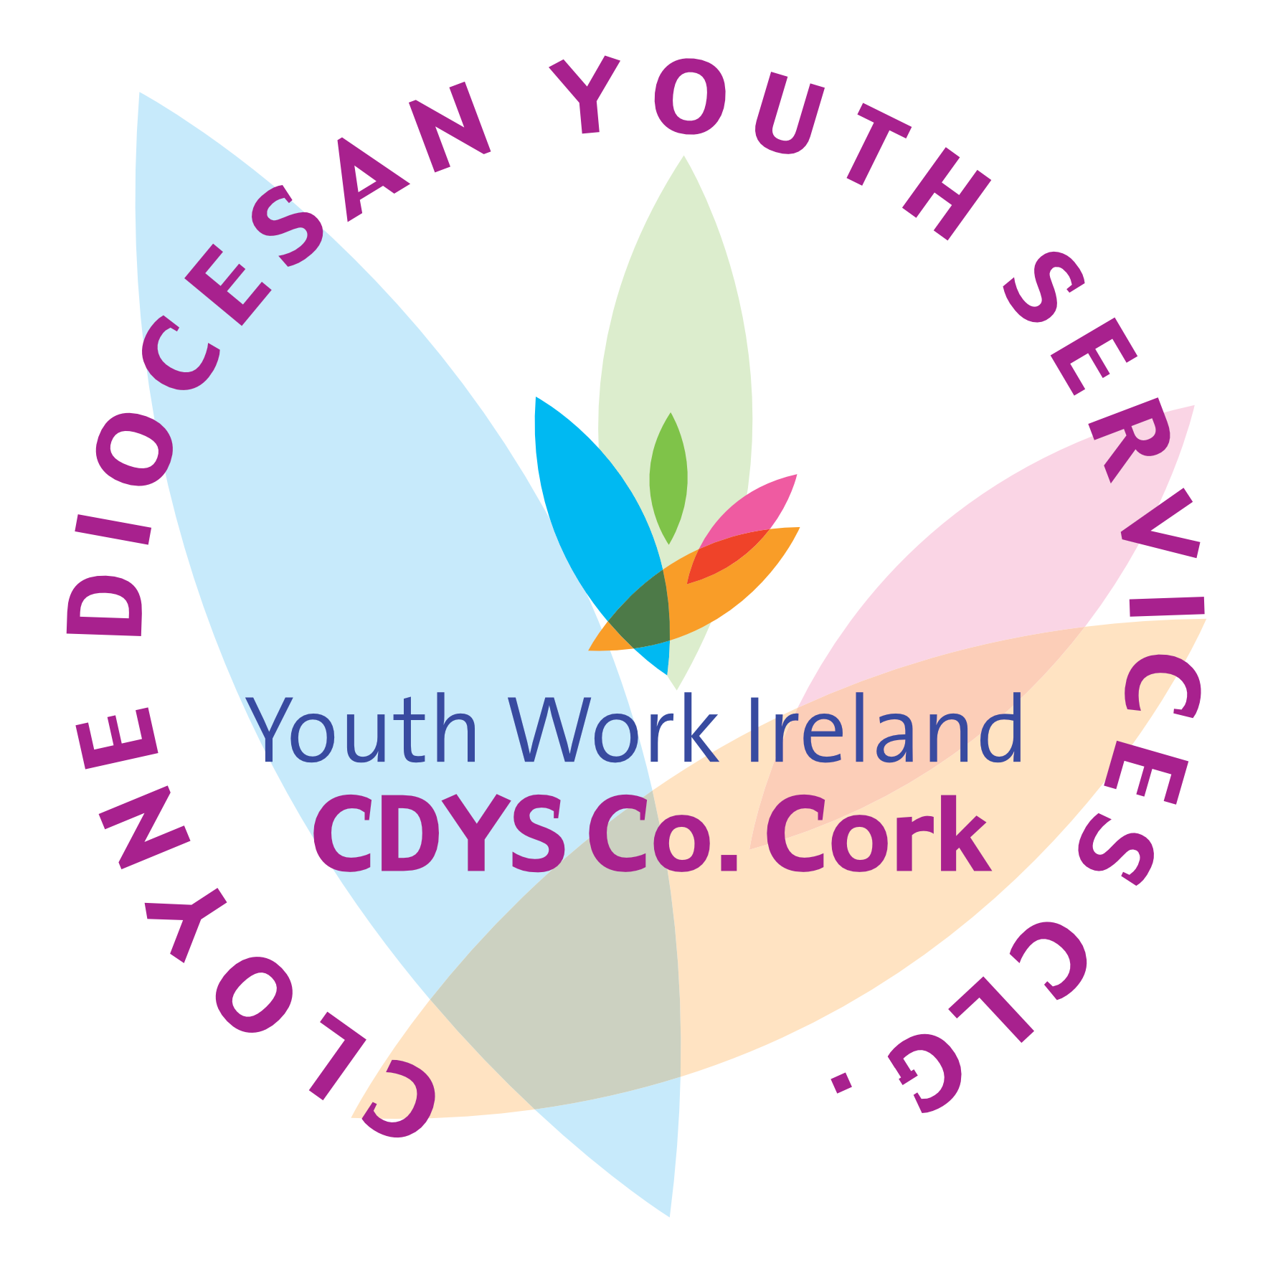

Cloyne Diocesan Youth Services CLG,
Youth Work Ireland-Co. Cork,

Mallow Community Youth Centre, New Road, Mallow

Phone: 022-53526/27 Fax 022-53456
www.cdys.ie
Website: www.cdys.ie

JOB DESCRIPTION
UBU Youth Worker

Job Title: Youth Worker

Immediate Supervisor: Line Manager

Main Purpose of job:

To provide a range of intervention activities and services allowing young people to:

OVERVIEW OF THE POST:
- Develop the character and self esteem of young people engaged in the project by providing a range of intervention activities and services based on their needs and in keeping to the definition of youth work
- Encourage young people to become responsible for their actions while encouraging them to think for themselves
- Build positive relationships with young people, their families, the community, and other relevant agencies or individuals engaged in the lives of young people
- Coordinate existing services and develop new services to respond to the needs of young people

KEY TASKS:
- Coordinate existing project, resources, and volunteers for the UBU project
- Represent CDYS locally and work in partnership with other agencies
- Act as an advocate to young people where necessary
- Support families of young people involved in local services and activities where relevant
- Produce reports, statistical information and complete grant applications where relevant
- Work budgets and resources within agreed structures
- Work in partnership with volunteers locally
- Work in partnership with CDYS staff and volunteers where necessary
- Provide a varied range of programmes in consultation with young people, staff and volunteers locally
- Attend CDYS events where required, this will include training, meetings and inter-project gatherings of young people
- Ensure effective communication by responding promptly to emails, calls etc
- Adhere to all standards, policies and procedures
- Consult with and support the local and regional youth council and support their work

Terms and Conditions:
- Competitive salary
- 25 days annual leave per annum (Pro Rata)
- Access to training and professional development through CDYS and Youth Work Ireland

Person Specification

Essential
- Third Level qualification in Youth Work or community work
- Minimum of one year full time experience of working in a community environment with young people.
- An ability to develop creative programmes
- Excellent communication and presentation skills.
- Excellent Team work experience coupled with initiative and drive
- High level of organisational, administrative and I.T. skills
- Experience of compiling reports and statistical information
- Experience of managing resources and working within budget constraints
- Have a proven ability to relate to people at all levels
- Be able to manage a diverse and challenging work load
- Be flexible and have a positive attitude to your work and your colleagues
- Experience of working with and supporting volunteers
- The ability to work to and promote the ethos and mission of CDYS CLG.
- Be flexible in your attitude and approach to your work.
- Be able to demonstrate leadership skills in past roles

Desirable
- Have an appreciation of partnership and community development
- Have an ability to represent the organisation at local level.
- Have some experience of training delivery and Youth Club Support
- Have a detailed understanding of youth related issues and their needs / requirements.

Personal Circumstances
- To be willing to work outside normal office hours to include evenings and weekends.
- To be wiling to travel locally, regionally and nationally.
- A full clean driving licence and own transport.

Personal attributes
- Have a commitment to promoting integration
- Be self-motivated and able to work as part of a team and on own initiative.
- A sense of humour and a willingness to try new initiatives.
- Have a commitment to the wellbeing of young people
- Have a commitment to best practice standards in youth work
- Cloyne Diocesan Youth Services is an innovative and responsive organisation that requires members of staff to be highly motivated, professional, flexible and committed to responding to the needs of young people and communities.

We also require all staff to have a positive and a can do approach to their work and to young people as well as working to the ethos and strategic aims of the organisation.

