**CITIZENS INFORMATION SERVICE**

**Regional Administrator**

**Full-time, Permanent Position**

Applicant Information Pack

April 2025

**Regional Administrator – Contents**

CIS Service Offer - **Page 3**

CIS Locations - **Page 4**

Job Description - **Page 5**

Person Specifications- **Page 7**

Required Competencies **– Page 8**

Terms and Conditions - **Page 10**

How to Apply **- Page 11**

**Citizens Information Service - Service Offer**

Citizens Information Services (CISs) provide free, impartial and confidential information, advice and advocacy services to the public. Each Citizens Information Service covers a geographical area within their region, facilitating both rural and urban areas, delivering a service through a network of Citizen Information Centres (CICs).

**Information and Advice**

Our Information Officers assist people with queries in relation to a broad spectrum of public and social services, including social welfare entitlements, income tax calculations, housing supports and access to health services. Our staff receive regular training and social policy updates to ensure that the information and advice that we provide is up-to-date and relevant for CIS service-users.

**Social Policy**

Our staff also engage in social policy reporting, highlighting issues that affect our clients in accessing public services, which in turn feeds into the work of the Citizens Information Board in the development of policy papers and recommendations to government. Through this process, CIS Information Officers capture social policy issues in real-time, facilitating the development of responsive and evidence-based policy reporting.

**Advocacy**

When required, Information Officers can provide further support through our advocacy service. This can mean assisting someone to write a letter or make a phone call, or a more complex and longer-term process such as preparing people for, or representing them at, a Social Welfare Appeals Office or Workplace Relations Commission hearing. All Information Officers are supported by a regional Advocacy Support Worker who provides expert advice, coaching and mentoring in this key aspect of our work.

The range and level of advocacy support provided by CISs has continued to develop and expand year on year, with significant outcomes achieved for people around the country in the areas including employment, equality, housing and social welfare.

**Citizens Information Services – Locations**

Each Citizens Information Regional Company covers a geographical region, facilitating both rural and urban areas, delivering a service through a network of Citizen Information Centres.

The 8 regional CIS companies cover the following areas: North Dublin, Dublin South, North Connacht & Ulster, North Leinster, North Munster, South Connacht, South Leinster and South Munster, as illustrated in the map below. Each CIS Region is subdivided into a number of CIS Service Areas which in turn each contain a number of Citizens Information Centres.

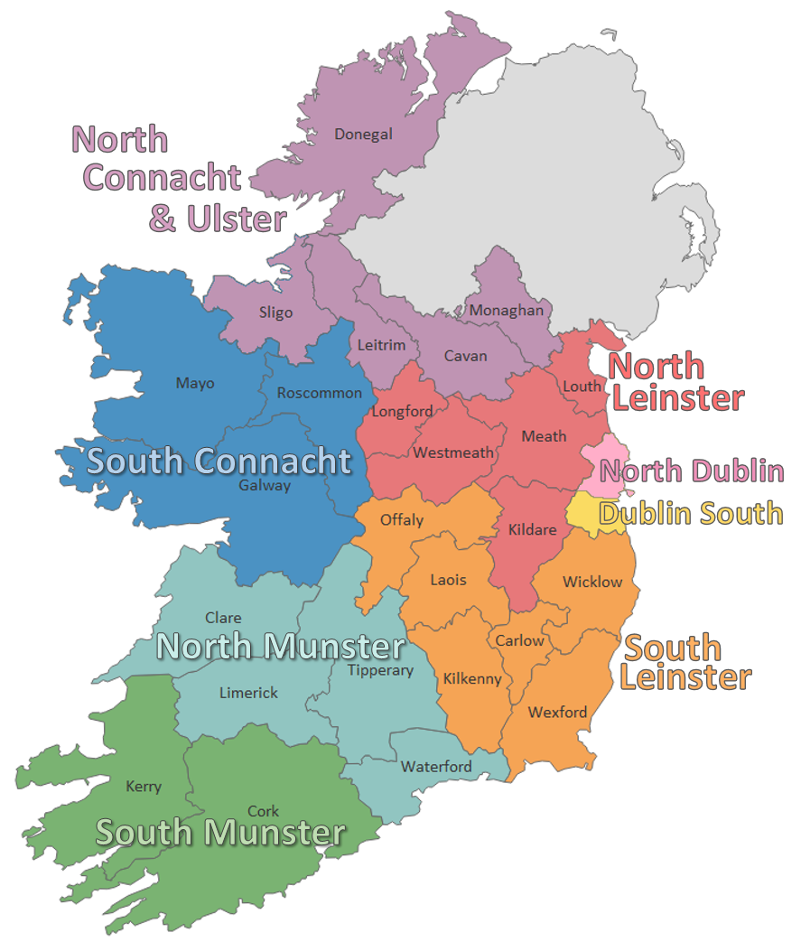

**Regional Administrator - Job Description**

**Purpose of the job:**

The primary role of the Regional Administrator is to provide and ensure high-level administrative support to the CIS Regional Manager. The Regional Administrator will assist the Regional Manager and Board of Directors as appropriate in the work of the CIS and the development of its services, and will ensure the maintenance and development of high quality administrative systems and practices throughout the organisation.

**Reporting to:** The Regional Manager

**Overview**:

The Regional Administrator will take primary responsibility for ensuring the development and maintenance of efficient, effective and carefully documented systems and practices across a range of key areas, and will ensure organisational compliance (under the direction of the Regional Manager) with all relevant legislation and with the requirements of the Citizens Information Board. These areas to include:

**Main Duties and Responsibilities**

***Financial Administration***

* To prepare and maintain, in cooperation with the Regional Manager and Board of Management, full and proper financial records of all transactions carried out on behalf of the company and where appropriate, preparing weekly payroll, bank transactions and submitting PAYE/PRSI returns.
* Monitor income and expenditure and assist Manager with preparation and monitoring of budgets
* Undertake all bookkeeping responsibilities, including payments and invoicing
* Liaison with creditors, debtors and financial institutions
* Monitor financial compliance and record-keeping as per Citizens Information Board (CIB) financial controls and any national/public sector guidelines/requirements applicable to Citizens Information Services
* Prepare regular financial reports (as per CIB reporting requirements, and as required by the Regional Manager, Treasurer and Board of Management)

***Company Governance***

* Provide administrative support in relation to CIS Board Meetings, including organisation of meetings; distribution of documentation; maintenance of contact lists; minute-taking if required – Board and Sub Committee Meetings; General Meetings (AGM/EGM)
* To prepare and assist in the collection of data for the monthly, quarterly and annual reports.
* Assist the Regional Manager with the production of reports as may be required – for submission to the Board of Management, Citizens Information Board and other internal and external bodies
* Prepare and file correspondence on behalf of the Regional Manager and Board of Management
* To be responsible for the compiling and collating of statistics for the Company and the Citizens Information Board.
* Maintain a contracts register for the company

***Office Management***

* To provide secretarial and administrative support, including typing, record keeping, filing, input and maintenance of data information etc. as required, in compliance with company’s responsibilities under Data Protection law and the GDPR
* Ensure the day-to-day running of the office is carried out in a professional and efficient manner, including responsibility for ensuring:
  + Adequate stocks of stationery and supplies
  + Maintenance, cataloguing and effective/accessible storage of an adequate stock of information resources
  + Ordering, auditing and maintenance of equipment
  + Effective storage systems and office layout
  + Liaising with contractors as required

**Other Responsibilities**

* Update the Regional Manager on a regular basis with respect to key administrative tasks and targets
* Undertake training and development to maintain and improve performance and assist in identifying self-training and support needs
* Attend seminars and meetings when directed by the Regional Manager and the Board.
* Provision of reception cover during opening hours of the service if required.
* Such other administrative duties as might be assigned by the Regional Manager.
* Liaison with Citizens Information Board and external service providers re all issues relating to ICT hardware and software

**Regional Administrator - Person Specifications**

**Essential Educational Qualifications and Attainments**

* Good general level of education - Leaving Certificate or equivalent
* Training with respect to financial administration and/or proven experience in financial administration/support

**Desirable Education Qualifications and Attainments**

A recognised qualification with respect to one or more of the following:

* Financial administration/accounting
* HR administration
* ICT

**Essential Knowledge, Skills & Experience**

* Minimum of 3 years’ experience in financial administration, book-keeping, and one or more of the areas detailed in the job description above
* Extensive ICT experience, to include high-level skills in all Microsoft programmes and computerised accounts, e.g. SAGE
* Ability to provide comprehensive secretarial and administrative support to the Regional Manager and Board
* Very strong organisational and ability to meet agreed work objectives on your own or as part of a team
* Excellent written, communication and numeracy skills
* Capacity to operate data storage and retrieval systems for reporting purposes (e.g. HR records management, customer feedback systems, etc.)
* Self-motivated, flexible and reliable
* Maintenance of the highest standards of honesty and integrity

**Desirable Knowledge, Skills & Experience**

* Senior administrative experience in a medium size organisation comparable with the Citizens Information Services
* Experience/Knowledge of the Citizens Information Services and / or company governance structures

Ability to work in a busy office, retaining focus at all times, and to prioritise workload accordingly.

**Regional Administrator – Required Competencies**

|  |  |
| --- | --- |
| **Competency** | **Definition** |
| **Secretarial and Administration** | Possesses the technical skills for the role including typing, record keeping, filing, and the inputting and maintenance of data.  Plans and prioritises effectively to meet targets and deadlines.  Identifies what needs to be done and takes responsibility for completing it in a systematic manner.  Possesses the technical skills for the role including typing, record keeping, filing, and the inputting and maintenance of data.  Possesses strong ICT skills.  Experienced in providing administrative support in a similar office environment. |
| **Financial Administration** | Ensures the maintenance and development of high quality financial administrative systems.  Maintains accurate financial accounts and produces clear and precise financial reports.  Uses relevant software efficiently to carry out accounting tasks (e.g. maintaining accounts, processing expenses claims, updating financial records, reports etc.). |
| **Information Management** | Understands the need to record and maintain data accurately on behalf of an organisation.  Processes and records company information accurately and appropriately. |
| **Company Governance** | Provides administrative support for senior management, including a board of management.  Supports management to maintain compliance with relevant regulatory bodies, e.g. Companies Registration Office, Charities Regulator. |

|  |  |
| --- | --- |
| **Competency** | **Definition** |
| **Communication** | Ability to communicate both orally and in writing in a clear, concise and professional manner.  Communicates in a confident manner with people at all levels, including staff, Board Members and external stakeholders.  Drafts correspondence, reports, bulletins, etc. in a clear and consistent tone. |
| **Team Working** | Actively participates as a team member and makes a useful contribution to the success of the team in relation to both performance and process.  Demonstrates an openness and receptivity to support, supervision and feedback and adapts approach in a constructive manner. |

**Regional Administrator – Required Competencies (cont.)**

**Regional Administrator – Terms and Conditions**

This is a permanent position, subject to satisfactory completion of a six-month probationary period. The period of probation may be extended at the discretion of the Regional Manager.

The successful candidate will be available to work 35 hours per week, (Monday to Friday). There may be a requirement to work evenings from time-to-time.

**Salary:**  Scale range of €30,130; €31,373; €32,611; €33,848; €35,081; €36,325; €37,560; €38,803; €41,143; LSI 1 €42,804, LSI 2 €44,467 (pro rata).

**Increm Incremental Credit:** It is expected, that all new entrants to North Leinster Citizens Information Service will be appointed at point one of the salary scale. However, North Leinster Citizens Information Service operates an incremental credit process for appointments higher than point one. This process is applicable to new entrants into North Leinster Citizens Information Service. Incremental credit criteria, based on the competencies for the role, are assessed against employment history as laid out in the application form only. A request for incremental credit from a successful candidate must be made within the first 3 months of employment. The decision on whether or not to award an incremental credit is a decision made by the Board and is subject to the availability of funding*.*

**Pension**: A company pension scheme is in place, and membership is obligatory upon commencement. Employee contribution; 5% of salary, Employer contribution; 7% of salary. Please note the Citizens Information Service has established a normal retirement age in line with the state pension age (currently 66).

**Annual Leave:** Calculated on a pro rata basis for part year service as follows:

* 23 days
* 24 days (upon completion of 2 years’ service)
* 26 days (upon completion of 5 years’ service)

Full terms and conditions are contained in a Staff Handbook, which is issued with and forms part of the Employee Contract.

**Regional Administrator – How to Apply**

* A relevant application form can be accessed at [www.citizensinformationboard.ie](http://www.citizensinformationboard.ie)
* Applicants must possess all required competencies for the role and will be shortlisted solely on the basis of information provided in their completed application form.
* Curriculum Vitae (CVs), late, incomplete or hand-written applications ***will not*** be considered.
* **Closing date:** 13:00pm on30th April 2025.
* **Please email application form to**: [recruitment.northleinstercis@citinfo.ie](mailto:recruitment.northleinstercis@citinfo.ie)
* If you require any reasonable accommodation to your application due to your circumstances (e.g. disability), please contact the above email address and we will try and facilitate you where reasonably practicable.  Successful applicants will be required to complete a writing skills assessment on the day of interview.
* A panel of qualified candidates may be formed from which permanent, full-time Regional Administrator posts which arise in a specified period, up to a maximum of 12 months, will be filled. Posts will be located in the CIS region applied for.
* For information on how your personal data will be used as part of this process please refer to our Data Protection Notice for Job Applicants, available at the following link:

<http://www.citizensinformationboard.ie/en/data_protection/cis.html>

***Citizens Information Services are equal opportunities employers***