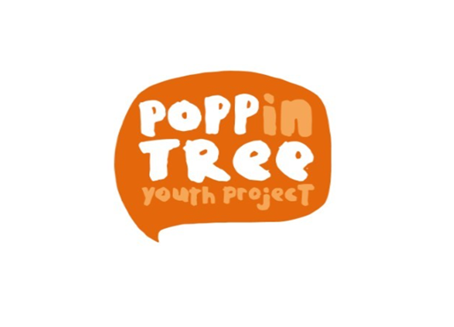

|  |  |
| --- | --- |
| **Employer:** | Poppintree Youth Project CLG |
| **Address:** | Poppintree Youth Project  Poppintree Community Sports Centre  Balbutcher Lane North  Ballymun  D11 E7WR |
| **Job Title:** | Full Time - UBU Youth Worker |
| **Service delivery hours** | 5 days, including 3 evenings and weekends in accordance with service delivery needs |
| **Salary scale** | €38,385 / € 40,833 / € 41,484 / € 44,750 / € 48,022 / € 51,302 / € 54,722 / € 56,447 |
| **Overall Purpose**  **of Job:** | Poppintree Youth Project is a community-based youth project working with young people aged 10-24. The project is funded through the UBU Funding Scheme. We are currently seeking to recruit a Full Time Youth Worker. This role is focused on leading and implementing a range of youth work programmes to meet the needs of young people. The Youth Worker will work with young people living in the catchment area of Poppintree in Ballymun. The work will be delivered through structured programmes that meet the developmental needs of young people who have been identified by the team. The Youth Worker will receive support and supervision as part of a Youth Team. |
| **Reporting to:** | The Project Leader, Poppintree Youth Project |
| **Key Areas of Work:** | **Programme Delivery and Development:**   * Plan, develop, deliver, and evaluate, inclusive developmental needs lead programmes , including issue and interest-based activities and programmes. * To ensure youth work programmes are inclusive and respond to the needs of young people. * Create feedback opportunities for young people to have their voices heard. * Liaise and advocate on behalf of young people and the community to other service providers and third parties where appropriate * To work in conjunction with relevant services where appropriate * To work and adhere to the child protection policy & best practices * Ensuring youth work approaches and methodologies are employed such as center-based programmes, group work, structured drop ins, and individual support. * Identifying young people who would benefit from the involvement in youth work programmes and activities. * Identifying potential volunteers and linking them into the training programme of the youth project. * Liaising with other agencies/ services working with young people and attending at meetings of these agencies/ services where appropriate and agreed. * Participating in relevant in-service training as agreed with the Project Leader.   **Administration:**   * Maintain records and files on all work with young people and update daily update internal recording management system. * Have a good understanding of the methods and frameworks used to record work with young people. * Can maintain accurate records of administration tasks. * Have a good working knowledge of the UBU Policy, National Youth Strategy, Better Outcomes/ Brighter Futures and Children First policy documents. * Completing youth work reports and presentations where requested.   **Genera**l:   * Work from a Community Development/Strengths’ Based Approach ethos. * Support the vision, mission and values of the organisation. * Operate within the PYP best practice guidelines and value base and community focused ethos in place within Poppintree Youth Project. * Work as part of a team, engaging in team meetings and appropriate supervision, evaluation, and planning sessions. * Working with colleagues in other areas of the organisation to deliver on community needs * Undertake additional duties as may be required from time to time. |
| **Person Specification** | **Professional Knowledge and Skills:**   * National recognised Qualification in Youth Work. * Proficient at planning, delivering, and evaluating programmes * Proficient IT skills, report writing, data collection. * A strong understanding of the principles of community-based youth work. * Demonstrates knowledge of key issues affecting the lives of young people in Poppintree in Ballymun. * Ability to communicate effectively and appropriately to young people across the target group age range. * Experience in delivering evidence based youth work programmes * Self-starter with the ability to work on own initiative. |
| **How to Apply** | To apply, please send CV and cover letter to [tdolan@poppinyp.ie](mailto:tdolan@poppinyp.ie).  **Closing date for applications is Friday May 9th 2025** |