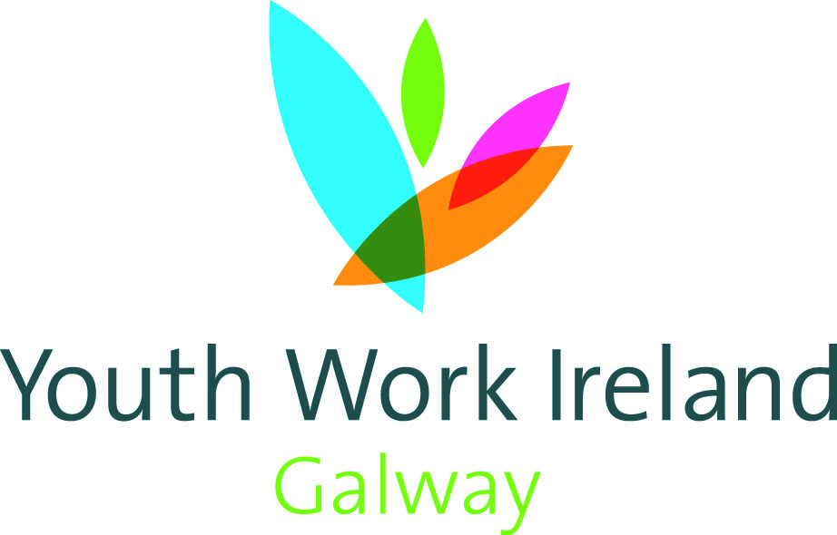

Job Description

Job Title | Ukraine Integration Support Youth Worker Fixed term
Location | Ballinasloe with outreach to Loughrea, Tuam and Galway City.
Reporting to | Managing Director
Youth Work Ireland Galway Mission | The Mission of Youth Work Ireland Galway is to support, empower and inspire young people to reach their full potential in a manner that is non-judgemental, welcoming and open. We do this by working in partnership with young people to provide a safe and supportive environment and range of services to all.
Role | To role of the Ukraine Community Youth Worker will be to co-ordinate the support and integration of Ukrainian young people into the Youth Work Ireland Galway Youth Projects and will support Ukrainian young people to access the services of Youth Clubs and sporting and social activities.
Duties and Responsibilities | - Supporting Young People  - Engage with young people and maintain a supportive and empowering relationship based on mutual respect and trust.  - Ensure that youth work programmes are designed to meet the identified needs of young people in the community following a needs assessment  - Use a strengths-based approach to support young people  - Support young people to actively participate in the planning and evaluation of the youth work programmes.  - Administration of the service  • Preparation of reports, statistics and other information that may be  required by funding agencies and the Managing Director.  - Record the number of individual young people who have fled from the war in Ukraine who are engaged in youth work by age group.  - Record numbers of young people who have fled from the war in Ukraine per type of support.  - Structured group work  - One to One support  - Unscheduled interventions  - Advocacy work: advocacy work with or on behalf of a young person/group of young people, including access to referral pathways.  - Programme Development and Delivery  - Provide a range of youth work programmes and activities for mainly out of school hours including evenings and weekends.  - Regularly evaluate the effectiveness of the programme and implement agreed changes  - Identify current and emerging needs and suggest programmes to address these needs.  - Keep up to date with best practice and developments in the field of youth work  - Carry out administrative tasks in accordance with organisation policies.  - Teamwork and Interagency Working  - Work in partnership with a variety of agencies to support young people in the local community.  - Work as part of a team and to participate in meetings in an active and constructive manner and supporting the ethos of the organisation.  - Have a flexible approach to the work in response to organisational change-development and review of best practice.  - Provide leadership and guidance to Community Employment staff, volunteers, students and/or others as required and directed by the Managing Director.  - Promote the service to potential users and the wider community.  - General duties  - Ensure that the protection and welfare of young people is a primary concern, and be aware of, and implement, local policy if concerns arise.  - Adhere to Youth Work Ireland Galway’s policies and procedures as contained in the Staff Handbook.  - Maintain accurate, professional written and electronic records of the work undertaken.  - Operate within policy, legal, ethical and professional boundaries when working with young people, ensuring the safeguarding of young people.  - Actively contribute to service review and development in a positive, solution focused manner.  - Participate in supervision with the Managing Director for individual support.  - Be knowledgeable about National Policy, Legislation and Guidance Frameworks pertaining to working with young people.  - Maintain up to date knowledge and skills as required by the role.  - Participate in fund raising and promotional activities.  - Agree to undertake other duties/responsibilities that are appropriate to the role.  Please be advised that this is not an exhaustive list of duties for the role and changes may occur. This role will require flexibility and adaption to new and changing situations on an ongoing basis.
Eligibility Criteria | Essential Qualifications and Experience  - Relevant third level qualification (QQI 7 or higher)  - Minimum of one years’ experience working with young people in a youth work setting.  - Understanding of child protection policies and procedures and the importance of safeguarding children, young people and vulnerable adults.  - Experience of engaging young people in community activities.  - Experience of supporting young people using strengths-based approach and utilising the principles of youth participation.  Desirable Qualifications and Experience  - Demonstrable experience of interagency working, to improve outcomes for young people and their families.  - Demonstrate experience of innovative programmes in responding to the needs of young people.
Skills and Competencies | - Competent level of IT skills  - Effective written and verbal communication skills with a range of individuals/groups  - Effective planning and organisational skills  - Ability to effectively plan and prioritise workload  - Committed to improving the outcomes for young people and their families.
Terms and Conditions | Contract:  May 2025- December 2025 months fixed term contract subject to funding  Hours: 28 hours/week; (including weekends)  Salary: Pt 1 of CDYSB Youth Worker Scale (pro rata)  Garda Vetting, and two satisfactory references, will be sought prior to the successful candidate taking up the post.

Youth Work Ireland Galway is an equal opportunities employer

