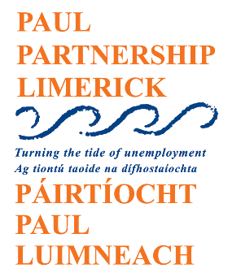
Call for Quotations (CFQ) – CRM System Development
Project Title: Development of a Client Relationship Management (CRM) System for PAUL Partnership Limerick CLG
Issued by: PAUL Partnership Limerick CLG
Location: Limerick, Ireland
Date Issued: 2nd April 2025
Response Deadline: 18th April 2025
1. Introduction
PAUL Partnership Limerick CLG is a not-for-profit local development company in Limerick city. We work with local communities, groups and individuals that have benefited least from economic and social development. We operate across 8 programmes, including key initiatives such as LAES, SICAP, and ABC Start Right.
We are seeking quotations for the design, development, and implementation of a tailored Customer Relationship Management (CRM) system. The goals of this CRM system are to:
- streamline our business processes,
- ensure we are providing an integrated service,
- improve data collection, evaluation and outcomes tracking,
- enhance communication with clients,
- improve the overall client experience and engagement across all our programmes.

2. Project Scope & Key Requirements
The CRM system should include the following core features:
- Data Storage & Management: including detailed client profiles, contact information, demographic data, programme participation details, engagement history, and individual client outcomes.
- Tracking Client Engagement: monitor client interactions, engagement levels, and progress through various services and programmes, including LAES, SICAP, ABC Start Right, and others.
- Tracking Client Outcomes: job placements, skills gained, or other relevant outcomes that measure the impact of our services.
- Automated Workflows: to streamline administrative tasks, such as follow-ups, reminders, and progress updates, to improve efficiency and client service delivery.
- Reporting and Analytics: Generate detailed reports and provide actionable insights on client engagement, programme outcomes, and service effectiveness to support decision-making and reporting requirements.
- Mobile and Web Access: Provide users with both web and mobile access for flexibility, ensuring staff can manage client data and workflows remotely.
- User Roles & Permissions: Allow for different access levels based on user roles to ensure data security and appropriate access to client information.

3. Technical & Operational Requirements
The following are the key requirements for the CRM system:
- Customisable Interface: A user-friendly, customisable dashboard and user interface to meet the specific needs of our team, making it easier to track client engagements and outcomes.
- Data Security: Implementation of robust security measures to protect sensitive client data, ensuring compliance with relevant data protection regulations.
- Integration with Existing IT Systems: The CRM should integrate with existing IT systems
- Ongoing Support and Maintenance: Provide post-deployment support and maintenance services to ensure the CRM remains effective and secure over time.

4. Submission Guidelines
Quotations must include the following details:
- Company Information: A brief description of your company and relevant experience developing CRMs.
- Project Approach: Outline of your proposed approach to the development of the CRM system, including design, development, testing, and deployment phases.
- Timeline: A detailed timeline for the project, including milestones and estimated delivery dates.
- Cost Breakdown: A comprehensive breakdown of the cost, including development, licensing (if applicable), maintenance, and any other associated fees.

Please submit your quotation to James Sheehan by 18th April 2025. For any enquiries or clarification, please contact jsheehan@paulpartnership.ie or 061 412999.

7. Terms and Conditions
- Quotations must be valid for a minimum of 30 days.
- PAUL Partnership Limerick CLG reserves the right to accept or reject any or all quotations received.

