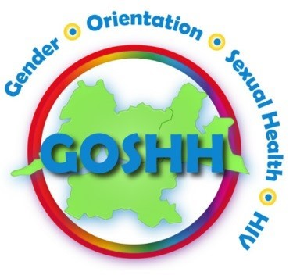

Sexual Health Promotion Worker

GOSHH is a leading organisation in the Midwest, providing a range of supports and services in the areas of Gender, Orientation, Sexual Health and HIV. Originally founded in 1980’s as Limerick AIDS Alliance and Gay Men’s Switchboard, we provide a safe, confidential, welcoming environment for everyone we work with.
We focus on the promotion of equality and well-being, with a positive and respectful approach to sexual orientation and gender identity and sexual health
We have an exciting opportunity for a full time Sexual Health Promotion worker to join our dynamic team. This role will involve collaboration with other team members in GOSHH to achieve the best possible outcomes for those accessing and benefitting from our services.

Benefits include:
- Generous annual leave entitlements
- Sick pay scheme, dental/medical leave
- Employee Assistance Scheme
- Bike to Work Scheme
- Taxsaver Travel Tickets
- Regular Internal and External supervision
- Training Opportunities and Team/Staff days

Job Description
This person will work to promote positive sexual health and well-being and co-
ordinate and develop sexual health training. Working with the team in GOSHH, they will build the capacity of individuals, groups and communities to improve sexual health outcomes and raise awareness of the services here in the Midwest

Responsibilities and Role

MAIN DUTIES
- To work in conjunction with other departments in GOSHH to provide sexual health programmes, talks and training
- To develop and promote sexual health services for all
- To increase visibility of the role and service through networking with agencies/statutory bodies and similar organisations within the wider sector
- To identify and target specific communities in need of safer sex and sexual health messages
- To support the testing team in provision of STI testing and outreach services
- To sit on working groups and sub-groups within the organisation where directed and appropriate
- Collaborate with management and other team members in relation to supports, training and strategic objectives of the organisation.
- To represent the organisation, where appropriate at events and on committees
- To record statistical data, contribute to annual reports and other working papers and submissions where required
- To assist in preparation of promotional material, social media posts, awareness and help in planning fundraising events

Successful candidate will have:
- A relevant professional qualification
- 12 months experience or equivalent of working in similar role
- Teamwork experience and skills
- Facilitation Skills desirable
- Strong communication and interpersonal skills
- Report writing and IT skills, including social media
- Proven ability of maintaining confidentiality
- An ability to reflect on personal development needs
- Warm, welcoming and non-judgemental attitude
- Driving licence and access to a car for work purposes

Salary: € 34,907.60
Contract: Full-time 35 hours per week, a 6 month probationary period.
Hours: Monday to Friday 9am to 5pm. Flexibility will be required in relation to events outside of normal working hours for which post holder will be entitled to time off in lieu
Holidays: 25 days a year

Garda Vetting: Please note that any offer of employment will be subject to Garda Vetting.
Closing date: Friday, 17th April 2025 at 12pm

To apply – please email/post CV and cover letter outlining your suitability
and interest in the role to Verena Tarpey, CEO at ceo@goshh.ie

