

**NORTH LEINSTER**

**CITIZENS INFORMATION SERVICE**

**The North Leinster Citizens Information Service invites expressions of interest for appointment as a Director of the Board (Three vacancies).**

**Closing Date: 8 April 2025 @ 13:00**

**Candidate Information Pack**

**March 2025**

**Contents**

Introduction 3

The Citizens Information Service Offer 4

Locations 5

Governance 6

Board Vacancy Details 8

Board Diversity 9

Person Specification 10

Application Process 11

Assessment Process 12

Data Protection 12

Confidentiality 12

Appendix 1 – Organisation Chart 13

Appendix 2 - Extract from Circular 13/2014 *(page 17)* 14

# Introduction

Citizens Information Services (CIS) are companies that allow callers to access face-to-face information on public and social services on a drop-in basis. There are Citizens Information Centres (CICs) right across Ireland, and these are supported by outreach locations and a mobile service. For more information, please see: <http://www.citizensinformation.ie>

The North Leinster Citizens Information Service (NLCIS) was founded in 2018 as part of a national restructure of the Citizens Information network. The company provides its service through a network of eleven (11) CICs and several ‘casual outreach’ services in Kildare, Longford, Louth, Meath and Westmeath.

The board is approaching the final phase of implementation of its agreed three-year strategic plan and has commenced the development of its next plan for 2025 onwards. Although an adjustment to the annual action plan was required due to COVID-19, the agreed strategic themes were broad enough to support the flexible and responsive approach required to continue operations throughout regularly changing public health restrictions.

# The Citizens Information Service Offer

Citizens Information Services (CISs) provide free, impartial, and confidential information, advice, and advocacy services to the public.

**Information and Advice**

Our Information Officers assist people with queries in relation to a broad spectrum of public and social services, including social welfare entitlements, income tax calculations, housing supports and access to health services. Our staff receive regular training and social policy updates to ensure that the information and advice that we provide is up-to-date and relevant for CIS service-users.

**Social Policy**

Our staff also engage in social policy reporting, highlighting issues that affect our clients in accessing public services, which in turn feeds into the work of the Citizens Information Board (CIB) in the development of policy papers and recommendations to government. Through this process, CIS Information Officers capture social policy issues in real-time, facilitating the development of responsive and evidence-based policy reporting.

**Advocacy**

If a person presents with a query or problem that we are not able to assist with through our drop-in information/advice service, Information Officers can provide further support through our advocacy service. This can mean a once-off engagement, such as assisting someone to write a letter or make a phone call, or a complex and longer-term process such as preparing people for, or representing them at, a Social Welfare Appeals Office or Workplace Relations Commission hearing.

The range and level of advocacy support provided by the CIS has continued to develop and expand year on year, with significant outcomes achieved for people around the country in the areas including employment, equality, housing, and social welfare. All Information Officers are supported by a regional Advocacy Support Worker who provides expert advice, coaching and mentoring in this key aspect of our work.

# Locations

Each Citizens Information Service covers a geographical region, facilitating both rural and urban areas, delivering a service through a network of CICs.

The eight (8) CIS companies cover the following areas: North Dublin, Dublin South, North Connacht & Ulster, North Leinster, North Munster, South Connacht, South Leinster, and South Munster, as illustrated in the map below. Each CIS Region is subdivided into several CIS service areas, which in turn each contain a number of Citizens Information Centres.

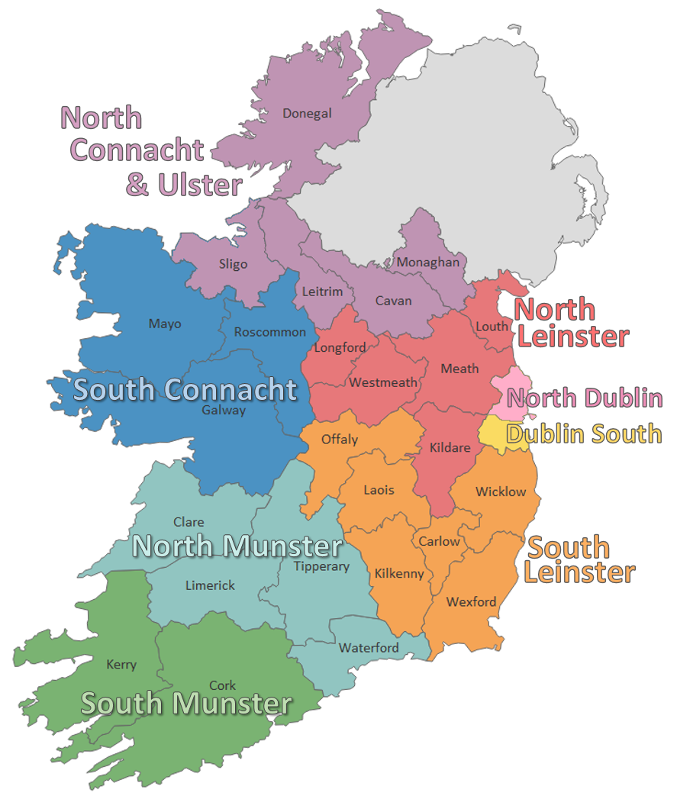

# Governance

**Functions of the Board**

The overall function of the board is to provide oversight of the delivery of the Citizen Information Service in accordance with a Service Level Agreement (SLA) with the funder, the Citizens Information Board (CIB).

High standards of corporate governance in community and voluntary boards are critical to ensuring a positive contribution to the state’s overall social and economic development.

The main object for which the company is established is the advancement of education and benefitting the community within the area through the provision of a free and confidential information, advice and advocacy service which informs, educates and empowers all individuals, without discrimination, by ensuring that individuals have access to accurate, comprehensive and clear information on their civil and social rights, entitlements and civic duties and of the social services that exist in the Area.

Board members must serve the interests of service users, the taxpayer, pursue value for money in their endeavours (including managing risk appropriately), and act transparently. [1]In line with the obligations of entities in receipt of public funding, regional boards must adhere to the principles of:

* Clarity
* Governance
* Value for Money
* Fairness

Board members should act on a fully informed basis, in good faith, with due diligence and care, and in the best interest of the organisation, subject to the objectives of the company.

An important role of the board members is to maintain the trust of the clients and customers in the independence of the Citizens Information Service.

**Charities Governance Code**

The board of NLCIS first declared compliance with the ‘Charities Governance Code’ in 2020. To ensure ongoing compliance with the code, the board established a committee, ‘The Governance Review Group’. This committee conducts regular reviews throughout the year and provides reports and recommendations to the board as appropriate.

**Compliance**

The company has compliance and reporting obligations to the CIB, CRO, CRA and Revenue. To ensure the company remains compliant in this area, the board has agreed an annual compliance calendar that it monitors regularly.

**Board Committees**

The board has established the following committees:

* Finance, Audit & Risk
* HR
* Service Delivery & Development
* Nominations
* Governance Review

Each board committee operates to a terms of reference and meets at least four (4) times per year. Board members are expected to be appointed to **at least one** board committee.

# Board Vacancy Details

The current board recruitment process is for **three** individuals with a particular focus on the following competencies:

**Vacancy 1** - HR or Workplace Relations; and/or

Financial Management/Internal Audit; and/or

Risk Management; and/or

Service Delivery (in an analogous environment)

**Vacancy 2** - HR or Workplace Relations; and/or

Financial Management/Internal Audit; and/or

Risk Management; and/or

Service Delivery (in an analogous environment)

**Vacancy 3** - HR or Workplace Relations; and/or

Financial Management/Internal Audit; and/or

Risk Management; and/or

Service Delivery (in an analogous environment)

The maximum board membership is ten (10) Directors, including the Chairperson.

This is a voluntary board and as a result, no fees are paid to board members. Travel and subsistence expenses will be paid to members where applicable.

There will be approximately eight meetings per annum, plus attendance at committee meetings, as required. Together with preparatory reading for meetings and follow up activities and information analysis, the total commitment could be up to 10 - 15 hours per month.

Each director shall be appointed to serve for a term of up to three years and may only serve for a maximum of two terms either consecutively or cumulatively.

To fulfil its functions, the board may establish committees/working groups to assist them in the effective and efficient performance of its responsibilities. All members will be expected to make themselves available to be a member of a committee. Composition of committees is a matter for the board, and this is reviewed on an annual basis.

Should more than **three** candidates be deemed suitable for appointment, the board may form a panel for any future vacancies (12 months), or a candidate may be offered a position on a board committee.

# Board Diversity

The board, in reviewing the diversity of the communities within which the organisation operates, realises the benefits that having similar diversity within its own membership will bring. In making any board appointments, consideration will be given to how the board makeup reflects and promotes diversity and inclusiveness to widen board influence and perspective.

The board are particularly interested in receiving expressions from individual with experience in a similar environment.

If you believe you would add value to our board but don’t meet all the criteria we have laid out in this advert, we would still love to hear from you. Please explain the value you would bring in your application.

# Person Specification

Board members must have an understanding of the values and importance of serving local communities and have governance experience and expertise.

Applicants should be able to demonstrate the following:

* An understanding of the work and remit of the CIS and the wider environment in which the organisation operates.
* The ability to critically analyse information, constructively challenge the opinions of others, work to a shared consensus and accept collective responsibility for board decisions.
* A strong awareness of good governance, including the ability to understand board level financial data, together with an appreciation of budgeting and sound financial management practices in relation to the significant state funding received from the CIB.
* The ability to take a broad perspective on the future strategic development of the organisation and its services.
* A strong sense of ethics and integrity together with a clear understanding of good governance practices including the role and responsibilities of boards and of individual directors in a modern context.
* Excellent communication skills, both oral and written
* A working knowledge of relevant legislation and obligations that Companies must adhere to e.g., Companies Act, Charities Act, Data Protection Legislation.
* The ability to work effectively with others and act to address any conflict, which may arise.

# Application Process

Having considered the general suitability criteria for membership of the NLCIS board, you should consider carefully how your background and experience fits with the specific appointment criteria set out in the person specification above. Please give careful consideration to the possibility of any potential conflict of interest that may arise if appointed to this board.

Please **email** your expression of interest (CV **and** a one-page cover letter) to [northleinstercis@citinfo.ie](mailto:northleinstercis@citinfo.ie). Please type *‘Board of Director Expression of Interest’* in the subject line.

Ensure your application clearly specifies how your particular background and experience meets the requirements of the board position(s) specified in this document.

**Closing date/time for receipt of applications is 13:00 on Tuesday 8th April 2025**

If you have any questions regarding the application process, please email the Regional Manager: [lorraine.walsh@citinfo.ie](mailto:rm.northleinstercis@citinfo.ie)

# Assessment Process

An assessment panel will be created and convened by the existing members of the board to consider and assess the expressions of interest received. The assessment will be based on a review of applicant’s documentation received.

The Panel will:

* Review and discuss the expressions of interest received against the specific appointment criteria for the role, as advertised in this information booklet.
* Assess potential candidates further once they meet the specified appointment criteria by undertaking any or all of the following steps:
  + Consideration of the written applications; and/or
  + Meeting/conference call; and/or - Referee checks; and/or
  + Any other selection or verification method deemed appropriate.
* Arrive at a shortlist of the most suitably qualified candidates (based on the information provided by the candidate) to be sent forward for consideration by the full board.

Please note that the NLCIS will not be responsible for any expenses incurred by candidates as part of our selection process.

# Data Protection

For details on how your personal data will be used as part of this process our Data Protection Notice is available at: <http://www.citizensinformationboard.ie/en/data_protection/cis.html>

# Confidentiality

Expressions of interest will be treated in strict confidence. All enquires, applications and all aspects of the selection process are treated as strictly confidential and are not disclosed to anyone, outside those directly involved in that aspect of the process.

**PLEASE NOTE:**

No person shall be eligible to be a board member if he/she is an employee of a CIB funded service or is an employee or board member of the CIB.

# Appendix 1 – Organisation Chart

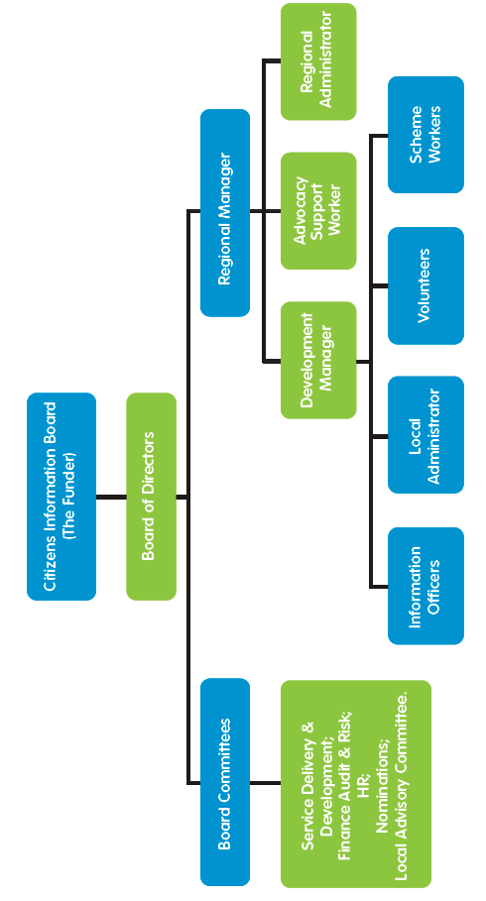

# Appendix 2 - Extract from Circular 13/2014 *(page 17)*

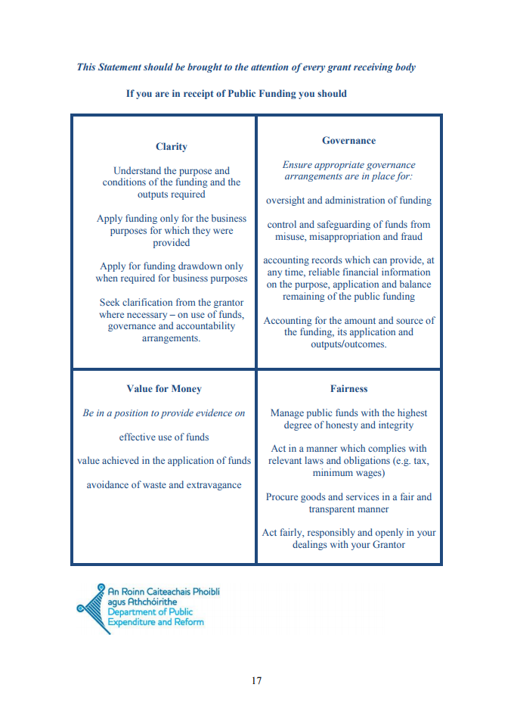

1. Extract from Circular 13/2014 page 17 see appendix 2