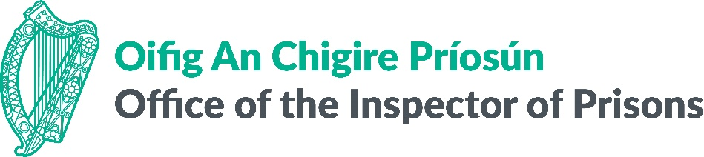

**Call for:**

**Expressions of Interest for   
OIP Expert Panel**

The Office of the Inspector of Prisons (OIP) is seeking Expressions of Interest for membership of its Expert Panel, which will support the OIP in carrying out its statutory activities. The panel includes experts from across a wide range of relevant disciplines.

At present, inspections are carried out by the OIP in accordance with [*A Framework for the Inspection of Prisons in Ireland* (2024).](https://www.oip.ie/wp-content/uploads/2024/12/A-Framework-for-the-Inspection-of-Prisons-in-Ireland-2024.pdf) The OIP currently evaluates compliance with national legislation ([Prison Rules](https://www.irishstatutebook.ie/eli/2007/si/252/made/en/print) 2007 – 2020) and international human rights standards, such as the European Prison Rules (2020), the UN Bangkok Rules (2011), the UN Mandela Rules (2015) and the standards developed by the Council of Europe’s European Committee for the Prevention of Torture (CPT).

In the near future, it is expected that the Inspectorate will become the Office of the Inspectorate of Places of Detention (OIPD) with an expanded mandate including inspection of detention by An Garda Síochána (the Irish National Police Service), court holding cells and detainee/prisoner transport. It is envisaged that the OIPD will be part of a multi-member National Preventive Mechanism (NPM), and will be the designated NPM for the criminal justice sector under the Optional Protocol to the United Nations Convention Against Torture (OPCAT).

Members of the Expert Panel should hold expertise, and the necessary qualifications, in the following areas (please note this is not an exhaustive list):

* Healthcare (Medical practitioners, Psychology/Psychiatry, Nursing, Addiction Specialists, Counsellors / Behavioural Therapists, etc.)
* Professionals with operational experience of working in and/or monitoring places of detention, including prisons and police stations
* Legal Professionals with human rights expertise
* Specialists, including with academic expertise, in areas such as nutrition, architecture/design, structural engineering and social sciences
* Specialists in Social and Cultural Services (Civil Society Representatives, Housing Experts, Employability / External Service Providers)

* Please note that applicants may be required to undergo Garda (Police) vetting

**Duration**

Expert Panel members may be invited to participate in the activities of the OIP/OIPD. Experts selected to participate in inspections will be expected to be available for 2-3 days per week during an individual prison inspection, with each inspection lasting for up to 2 weeks. Experts participating in inspections and/or investigations will be expected to prepare and provide detailed notes and a draft report on their findings.

**Location**

Prisons and – in due course – other places of detention in Ireland.

**Compensation**

Competitive per-diem compensation rates will be provided based on the status and level of expertise of the Expert Panellist. These rates are applicable to all Expert Panellist activities (preparation, inspection, analysis and report-writing, etc.). For each inspection, the OIP will agree the total days required of the Expert Panel member.

Standard [Civil Service Travel and Subsistence](https://www.revenue.ie/en/employing-people/employee-expenses/travel-and-subsistence/civil-service-rates.aspx) apply.

**A Table of Professional Fees is available upon request.**

Fees are payable subject to compliance with the ‘*One Person One Salary’* (OPOS) principle, in respect of serving public sector employees and must be met from within the existing funding allocation. In addition, these fees are subject to taxation (see, ‘Income Tax – Statement of Practice SP-IT/04’ for details).

**Tax Clearance**

Experts selected to participate in visits may be asked to provide evidence (for example, a tax clearance certificate) indicating that they are fully tax compliant.

**Overall Objective**

To support the OIP/OIPD in carrying out its statutory functions.

**Key Tasks**

Experts may be tasked with:

* Attendance at meetings
* Review of materials on monitoring treatment and conditions – relevant to area
* Participation in an inspection or investigation of a prison/other places of detention

- on-site inspection/investigation

- meetings, including debriefs and closeout meetings

* Development and submission of a draft report to the OIP, which will be used to inform inspection and investigation reports

Activities during the course of inspections and investigations will include, but are not limited to:

* Review of records, logs and other documentation
* Review of policies and practice, and review of adherence to same
* Private interviews with people in prison, prison staff, service providers
* Consultation and collaboration with OIP/OIPD staff

**Required Outputs:**

* Notes taken during the course of inspection / investigation
* Draft report outlining key concerns, good practice and recommendations for improvement of outcomes

**Submission**

Please submit the application form to [info@oip.ie](mailto:info@oip.ie) with the subject line “OIP Expert Panel” by **Wednesday 30 April 2025.** Questions about the Expert Panel may also be submitted in advance of submitting an application.

