|  |  |
| --- | --- |
| **Job title** | Senior Community Support Officer |
| **Main Function** | NOW Group are an award-winning social enterprise who deliver services across the island of Ireland supporting people with intellectual disabilities, autism and neurodiverse conditions into jobs with a future.  We are passionate about changing lives and our focus is on outcomes and impact for individuals, their families and communities who are the most disadvantaged.  We support participants to have better health, a better education and a brighter future.  Our services are continually evolving as a result of co-design, participant feedback and project learning.  As a Senior Community Support Officer you will lead NOW Group’s Community Opportunities programme by supporting our participants in their journey from school to further education, developing their independence and soft skills to prepare them for training and employment. You will liaise directly with a range of stakeholders including schools and Further Education Colleges to identify students who will transition into NOW Group services and support placements through our social enterprise cafes. |
| **Location** | Dublin 7 - on site role |
| **Reports to** | Community Development Manager |
| **Hours** | 37.5 hours per week |
| **Salary scale** | €38,000 per annum |
| **Benefits** | 25 days annual leave plus 11 statutory days (pro-rata)  Health Cash Plan (on successful completion of probationary period)  Access to confidential Staff Counseling  Pension Scheme (on successful completion of probationary period)  Holiday purchase scheme  Flexible working initiatives  Wellbeing initiatives |

**Mission**

Supporting people with intellectual disabilities and autism into jobs with a future.

**Vision**

A society where people with intellectual disabilities live, work and socialise as valued citizens.

**Main Responsibilities**

1. Manage NOW Group’s Community Opportunities programme ensuring the service is planned and implemented to fulfill NOW Group strategic and operational plans and the needs and aspirations of key stakeholders.
2. Line management of of Community Support Officers to deliver a programme of high-quality activity sessions.
3. Ensure effective induction of new and existing participants, including initial and formative assessments and the co-creation of Outcome Stars and Action Plans.
4. Co-ordinate a monthly calendar of varied activities and sessions focused on independence and soft skills development for participants.
5. Provide support to participants as required, advising the team on how to provide person-centered support and how to signpost to other support services if appropriate.
6. Engage in meaningful dialogue with service users and families to ensure that they have a role in shaping service delivery.
7. Establish and develop effective working relationships between schools, social work teams, community support services, parents/carers and employers to ensure a range of opportunities for each young person leaving school.
8. Work with the Employment and Training team to support participants to transition into our other services based on participant needs and aspirations.
9. Liaise with our marketing and communications service to create positive promotional material and individual case studies.
10. Undertake regular quality audits to ensure compliance with organisation and funder guidelines.
11. Contribute to the achievement of organisation Scorecard targets and strategy objectives.
12. Comply fully with NOW Group's 'Organisation Approach to Safeguarding' and adopt the role of Designated Safeguarding Officer.

**This job description is not definitive and may be subject to review as the duties and responsibilities determine.**

**Please note that employment with NOW Group may be subject to a check from the Garda Vetting Bureau.**

**Personnel Specification**

Essential

1. Minimum of one year’s experience supporting people with intellectual disabilities/difficulties or autism.
2. Minimum of one year’s experience managing a team or project and meeting targets.
3. Educated to Leaving Certificate level or above.
4. Clear understanding of the barriers experienced by people with intellectual disabilities/difficulties when engaging in social or community-based activities.
5. Proficient in the use of the Microsoft Office suite.
6. Excellent communication skills and public speaking/presentation skills.

**Desirable**

1. Certified Qualification (ideally to degree level) in a relevant discipline e.g., Community Work or Social Care.
2. Experience of building and maintaining local networks.
3. Experience overseeing quality auditing processes.

**Shortlisting will be based on the evidence that you supply on your application form to satisfactorily demonstrate how, and to what extent, you meet the above criteria. The Shortlisting Panel will not make assumptions as to your circumstances, qualifications, and experience.**

**Values & Behaviours**

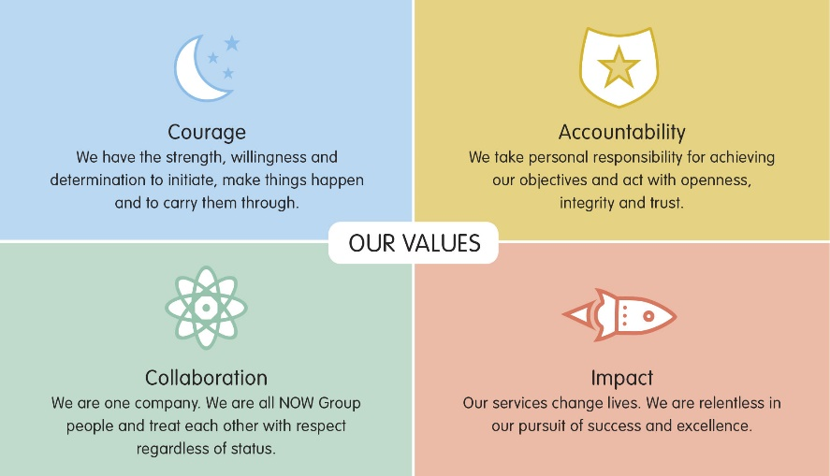

All employees in NOW Group are required to subscribe to the values of the organisation and demonstrate these values through agreed behaviours in their day-to-day work and their relationships with participants, stakeholders and colleagues. **Candidates will be expected to demonstrate relevant values and behaviours as part of the interview process.**