|  |  |
| --- | --- |
| **Job title** | Employment Officer |
| **Candidate Brief** | NOW Group are an award-winning social enterprise who delivers services across the island of Ireland supporting people with intellectual disabilities, autism and neurodiverse conditions into jobs with a future.  We are passionate about changing lives and our focus is on outcomes and impact for individuals, their families and communities who are the most disadvantaged.  We support participants to have better health, a better education and a brighter future.  Our services are continually evolving as a result of co-design, participant feedback and project learning.  As Employment Officer you will work hand in hand with our participants to support them into long-term sustainable employment and achieve their goals. You will have a particular focus on securing jobs for participants while promoting learning and work experience. The Employment Officer will engage effectively with parents, carers and employers in a professional manner to ensure that optimum opportunities and outcomes can be achieved by the participants. |
| **Location** | Dublin 7 - on site role for initial probationary period |
| **Reports to** | Employment Development Manager |
| **Hours** | 37.5 hours per week |
| **Salary scale** | €38,000 per annum |
| **Benefits** | 25 days annual leave plus 11 statutory days (pro-rata)  Health Cash Plan (on successful completion of probationary period)  Access to confidential Staff Counseling  Pension Scheme (on successful completion of probationary period)  Holiday purchase scheme  Flexible working initiatives  Wellbeing initiatives |

**Mission**

Supporting people with intellectual disabilities and autism into jobs with a future.

**Vision**

A society where people with intellectual disabilities live, work and socialize as valued citizens.

**Main Responsibilities**

1. Mentor and support participants throughout their individual journey towards employment, providing person-centered support to help them achieve their goals. This will include organising job clubs, sourcing work placements, support with job searching, applications and interviews to gain paid and voluntary jobs.
2. Support participants to achieve their learning goals through motivation and encouragement to participate in training and soft skills sessions.
3. Ensure effective induction of participants, carrying out initial and formative assessments and completion of quarterly Outcome Star reviews and associated action plans.
4. Develop and maintain strong working relationships with a network of employers to secure employment opportunities for participants.
5. Develop links with potential referral agencies for future participants e.g. Job Centres, Schools, Colleges.
6. Represent and promote NOW Group in the relevant geographical areas through development of links with statutory agencies/local community networks and appropriate stakeholders.
7. Contribute to the achievement of targets within the Organisational Scorecard and NOW Group’s strategic objectives.
8. Promote the NOW Group brand and tell our story through social media engagement, event attendance, use of marketing materials and other key communication tools.
9. Take part in regular quality audits to ensure compliance with organisation and funder guidelines.
10. Comply fully with NOW Group's 'Organisational Approach to Safeguarding.’

**This job description is not definitive and may be subject to review as the duties and responsibilities determine.**

**Please note that employment with NOW Group may be subject to a check from the Garda Vetting Bureau.**

**Personnel Specification**

Essential

1. Minimum one year’s paid experience of working with either:

* Participants with learning or intellectual disabilities/difficulties.
* Experience assisting individuals into work.
* Experience of liaising with employers.

1. Educated to Leaving Certificate level or above.
2. Ability to demonstrate administrative skills with good record keeping.
3. Excellent level of IT (including social media skills), communication skills and presentation skills.
4. Clear understanding and articulation of the principles of supported employment.

**Desirable**

1. Certified Qualification (ideally to degree level) in a relevant discipline e.g. Community Work or Career Guidance.
2. Proven track record of securing employment for people with barriers to learning.
3. Experience of building local networks.
4. Experience participating within the quality auditing processes.

**Shortlisting will be based on the evidence that you supply on your application form to satisfactorily demonstrate how, and to what extent, you meet the above criteria. The Shortlisting Panel will not make assumptions as to your circumstances, qualifications, and experience.**

**Values & Behaviours**

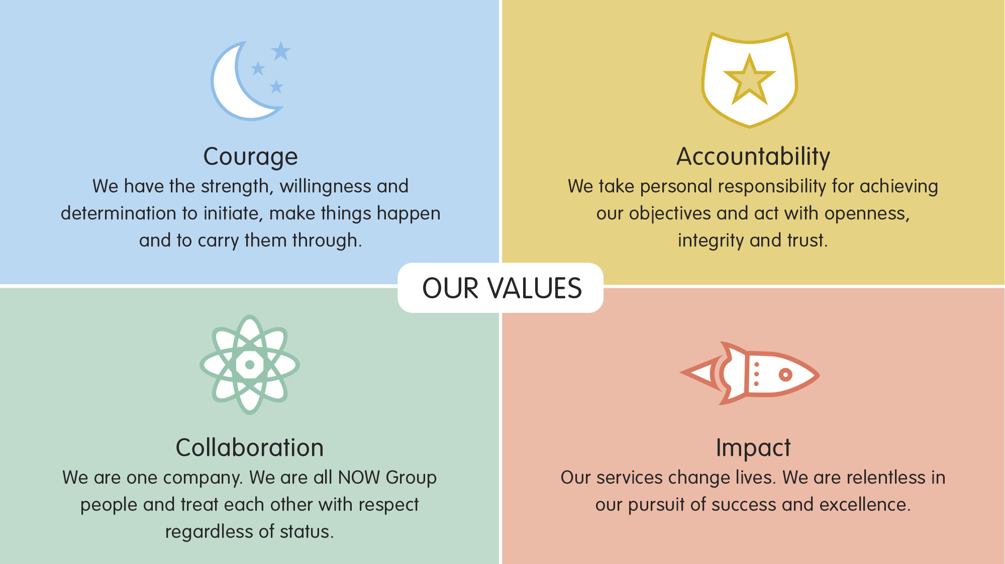

All employees in NOW Group are required to subscribe to the values of the organisation and demonstrate these values through agreed behaviours in their day-to-day work and their relationships with participants, stakeholders and colleagues. Candidates will be expected to demonstrate relevant values and behaviours as part of the interview process.