|  |  |
| --- | --- |
| **Job title** | Employment Development Manager |
| **Candidate Brief** | NOW Group are an award-winning social enterprise who deliver services across the island of Ireland supporting people with intellectual disabilities, autism and neurodiverse conditions into jobs with a future.  We are passionate about changing lives and our priority is on outcomes and impact for individuals, their families and communities who are the most disadvantaged.  We support participants to have better health, a better education and a brighter future.  Our services are continually evolving as a result of co-design, participant feedback and project learning.  As Employment Development Manager you will be responsible for the management and staff of our Employment programme, with a particular emphasis on employer engagement to create job opportunities for our participants. |
| **Location** | Dublin 7 - on site role for initial probationary period |
| **Reports to** | Regional Manager |
| **Hours** | 37.5 per week |
| **Salary scale** | €44,000 per annum |
| **Benefits** | 25 days annual leave plus 11 statutory days (pro-rata)  Health Cash Plan (on successful completion of probationary period)  Access to confidential Staff Counseling  Pension Scheme (on successful completion of probationary period)  Holiday purchase scheme  Flexible working initiatives  Wellbeing initiatives |

**Mission**

Supporting people with learning difficulties and autism into jobs with a future.

**Vision**

A society where people with learning difficulties live, work and socialize as valued citizens.

**Mission**

Supporting people with learning difficulties and autism into jobs with a future.

**Vision**

A society where people with learning difficulties live, work and socialize as valued citizens.

**Main Responsibilities**

1. Develop strong working relationships with local stakeholders to create new employment opportunities for people availing of NOW Group services.
2. Forge NOW Group’s reputation as a trusted business partner that delivers real social and commercial benefit to local employers.
3. Engage in meaningful dialogue with participant cohorts, ensuring that the participants have a role in shaping service delivery (co-design).
4. Represent NOW Group at events by delivering presentations, participating in discussions and explaining the work of the NOW Group.
5. Work alongside marketing on key employer engagement activity including events, communication strategies and marketing materials, including social media engagement.
6. Lead and line manage the Catering Trainer, including work allocation, training, problem resolution and evaluating performance.
7. Assist in the selection and appointment of staff, paid and voluntary, and ensure effective management of
8. Produce accurate monitoring and reporting on progress against targets internally and externally to funders and business partners.
9. Undertake regular quality audits to ensure compliance with organisational and funder guidelines.
10. Contribute to the achievement of organisational Scorecard targets and strategy objectives.
11. Comply fully with NOW Group's 'Organisational Approach to Safeguarding' and adopt the role of Designated Safeguarding Officer.

**This job description is not definitive and may be subject to review as the duties and responsibilities determine.**

**Please note that employment with NOW Group may be subject to a check from the Garda Vetting Bureau.**

**Personnel Specification**

Essential

1. A Third level graduate, health and social care equivalent
2. Well-developed people management skills, with proven experience of building, leading and motivating a team.
3. Experience in the development of relationships with stakeholders in the provision of health & social care services.
4. Experience in the promotion and support of independent living and community integration for service users.

**Desirable**

1. CPI Verbal Intervention & CPI Safety Intervention
2. Occupational First Aid

**Shortlisting will be based on the evidence that you supply on your application form to satisfactorily demonstrate how, and to what extent, you meet the above criteria. The Shortlisting Panel will not make assumptions as to your circumstances, qualifications, and experience.**

**Values & Behaviours**

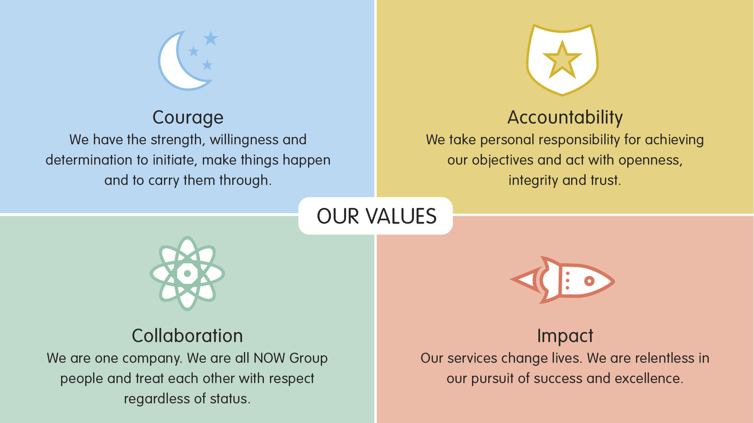

All employees in NOW Group are required to subscribe to the values of the organisation and demonstrate these values through agreed behaviours in their day-to-day work and their relationships with participants, stakeholders and colleagues. Candidates will be expected to demonstrate relevant values and behaviours as part of the interview process.