|  |  |
| --- | --- |
| **Job title** | Community Support Officer |
| **Candidate Brief** | NOW Group are an award-winning social enterprise who deliver services across the island of Ireland supporting people with intellectual disabilities, autism and neurodiverse conditions into jobs with a future.  We are passionate about changing lives and our focus is on outcomes and impact for individuals, their families and communities who are the most disadvantaged.  We support participants to have better health, a better education and a brighter future.  Our services are continually evolving as a result of co-design, participant feedback and project learning.  As Community Support Officer you will provide direct support to participants on NOW Group’s Community Opportunities programme by delivering a programme of daily activities to increase independent living and social skills. The post holder will work closely with other departments including our Employment and Training Services to encourage and support participants on their journey of progression from community services. |
| **Location** | Dublin 7 – on site role |
| **Reports to** | Community Development Manager |
| **Hours** | 37.5 hours per week |
| **Salary scale** | €34,000 per annum |
| **Benefits** | 25 days annual leave plus 11 statutory days (pro-rata)  Health Cash Plan (on successful completion of probationary period)  Access to confidential Staff Counseling  Pension Scheme (on successful completion of probationary period)  Holiday purchase scheme  Flexible working initiatives  Wellbeing initiatives |

**Mission**

Supporting people with intellectual disabilities and autism into jobs with a future.

**Vision**

A society where people with intellectual disabilities live, work and socialise as valued citizens.

**Main Responsibilities**

1. Provide person-centered support to participants on the NOW Connects programme.
2. Support participants within classroom and outdoor venues.
3. Encourage individuals to engage in opportunities and build independence skills.
4. Promote Volunteer opportunities for group members.
5. Build on existing external networks/relations and develop new ones to increase the range of activities and networks available to participants.
6. Route train participants to increase independence skills.
7. Work effectively with NOW Group Services to provide a full range of support, optimizing positive progression for participants.
8. Ensure organisational, team and individual annual KPIs are met.
9. Ensure accurate record keeping of participant attendance, retention and progression in compliance with organisational data protection and confidentiality policy.
10. Comply fully with NOW Group's 'Organisational Approach to Safeguarding’.

**This job description is not definitive and may be subject to review as the duties and responsibilities determine**

**Please note that employment with NOW Group may be subject to a check from the Garda Vetting Bureau.**

**Personnel Specification**

Essential

1. Minimum one years' experience of supporting people with intellectual disabilities within a group environment.
2. Educated to Leaving Certificate level or above.
3. Experience of engaging with volunteers.
4. Ability to demonstrate administrative skills with good record keeping.
5. Proficient in the use of the Microsoft Office suite.
6. Clear understanding and articulation of the barriers faced by people with intellectual disabilities or autism.

**Desirable**

1. Certified Qualification (ideally to degree level) in a relevant discipline e.g. Community Work or Youth Work
2. Proven track record of securing employment for people with barriers to learning.

**Shortlisting will be based on the evidence that you supply on your application form to satisfactorily demonstrate how, and to what extent, you meet the above criteria. The shortlisting panel will not make assumptions as to your circumstances, qualifications, and experience.**

**Values & Behaviours**

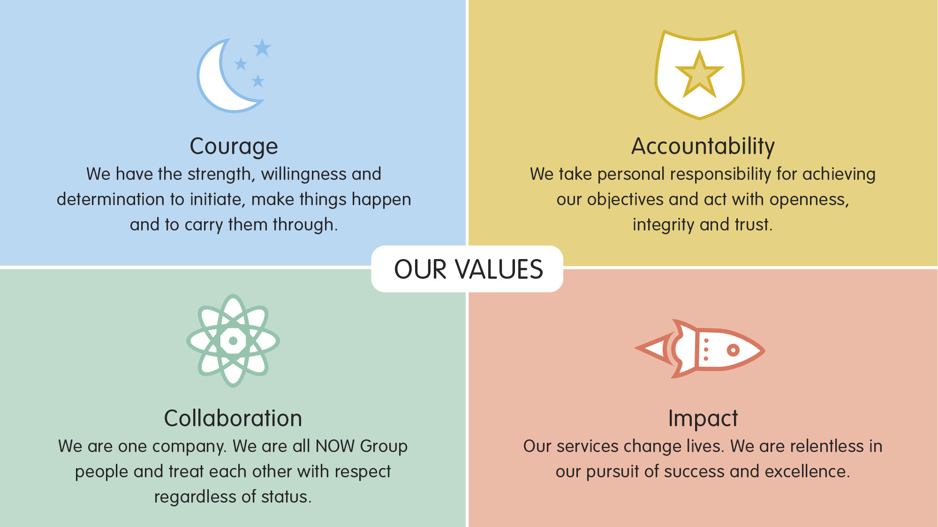

All employees in NOW Group are required to subscribe to the values of the organisation and demonstrate these values through agreed behaviours in their day-to-day work and their relationships with participants, stakeholders and colleagues.

**Candidates will be expected to demonstrate relevant values and behaviours as part of the interview process.**