|  |  |
| --- | --- |
| **Job title** | Community Development Manager |
| **Main Function** | NOW Group are an award-winning social enterprise who deliver services across the island of Ireland supporting people with intellectual disabilities, autism and neurodiverse conditions into jobs with a future.  We are passionate about changing lives and our focus is on outcomes and impact for individuals, their families and communities who are the most disadvantaged.  We support participants to have better health, a better education and a brighter future.  Our services are continually evolving as a result of co-design, participant feedback and project learning.  As Community Development Manager you will be responsible for the day-to-day management of NOW Group’s Community Opportunities programme. You will manage all new Community projects with an emphasis on networking, community engagement, sourcing and on boarding referrals, while leading and developing the community staff team. |
| **Location** | Dublin 7 – on site role |
| **Reports to** | Regional Manager - Dublin |
| **Hours** | 37.5 hours per week |
| **Salary scale** | €42,000 per annum |
| **Benefits** | 25 days annual leave plus 11 statutory days (pro-rata)  Health Cash Plan (on successful completion of probationary period)  Access to confidential Staff Counseling  Pension Scheme (on successful completion of probationary period)  Holiday purchase scheme  Flexible working initiatives  Wellbeing initiatives |

**Mission**

Supporting people with intellectual disabilities and autism into jobs with a future.

**Vision**

A society where people with intellectual disabilities live, work and socialize as valued citizens.

**Main Responsibilities**

1. Manage NOW Group's community initiatives ensuring services are planned and implemented to fulfill NOW Group strategic and operational plans and the needs and aspirations of key stakeholders.
2. Lead and line manage the community services team, including work allocation, training, problem resolution and evaluating performance.
3. Ensure effective induction of participants, including initial suitability meetings and formative assessments and the co-creation of Outcome Stars and Action Plans.
4. Engage in meaningful dialogue with service users and families to ensure that the participants have a role in shaping service delivery.
5. Work with community team to identify trends in participant’s needs, gaps in provision, developing suitable project proposals and leading on implementation of new projects.
6. Work with Employment and Training team to support participants to transition from community into our other services based on participant needs and aspirations.
7. Develop excellent relationships with partners and stakeholders, representing NOW at events by delivering presentations, participating in discussions and explaining the work of the organisation.
8. Liaise with our marketing and communications service to create positive promotional material and individual case studies.
9. Produce accurate financial returns and monitor and report on progress against targets internally and externally to funders and business partners.
10. Undertake regular quality audits to ensure compliance with organisation and funder guidelines.
11. Contribute to the achievement of organisation Scorecard targets and strategy objectives.
12. Comply fully with NOW Group's 'Organisation Approach to Safeguarding' and adopt the role of Designated Safeguarding Officer.

**This job description is not definitive and may be subject to review as the duties and responsibilities determine**

**Please note that employment with NOW Group may be subject to a check from the Garda Vetting Bureau.**

**Personnel Specification**

Essential

1. Certified Qualification (ideally to degree level) in a relevant discipline e.g. Community Work or Youth Work
2. Educated to Leaving Certificate level or above.
3. Minimum three years’ paid experience of supporting people with intellectual disabilities within a group environment
4. Minimum two years’ experience of managing a team and/or project and meeting targets.
5. Minimum two years' experience of producing internal or external monitoring reports.
6. Proficient in the use of the Microsoft Office suite.

**Desirable**

1. Experience of managing service level agreements with Health and Social Care Trusts.
2. Experience of managing a budget.

Shortlisting will be based on the evidence that you supply on your application form to satisfactorily demonstrate how, and to what extent, you meet the above criteria. The shortlisting panel will not make assumptions as to your circumstances, qualifications, and experience.

**Values & Behaviours**

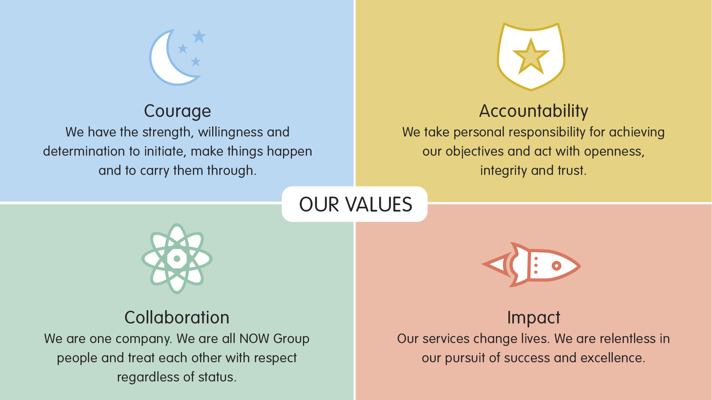

All employees in NOW Group are required to subscribe to the values of the organisation and demonstrate these values through agreed behaviours in their day to day work and their relationships with participants, stakeholders and colleagues. **Candidates will be expected to demonstrate relevant values and behaviours as part of the interview process.**