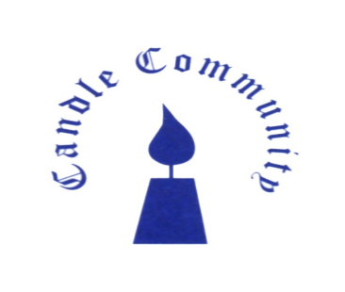
Application Form
Co-Ordinator, Therapeutic Services

Name:
Address:
Email Address:
Telephone Number:

All sections of this Form must be completed in full.
Candidates should note that the information supplied in this Application Form will play a central part of the short-listing process. Anything you submit may be discussed in more depth should you be invited to interview.
Please submit your completed Application Form, together with your CV and cover letter to: Info@candletrust.ie

Reflecting on your experience to date, please respond to the following statements. In each case, be specific by giving examples and avoid making general statements. In each case use a 300-word count as a guide.

Working Therapeutically
Describe your qualifications and experience in psychotherapy.

Leadership and Programme Management
Detail your experience of leading out a project and delivering on outcomes.

Team Collaboration
Provide your experience of working as part of a team and how you built team culture, responsibility, and accountability.

Application:
Please send a Cover Letter, CV and completed Application Form to:
info@candletrust.ie

Closing date for receipt of application is Monday, April 7th, 2025.
First Interviews will be held on the week of April 14th, 2025.

Candle Community Trust is an Equal Opportunities Employer

