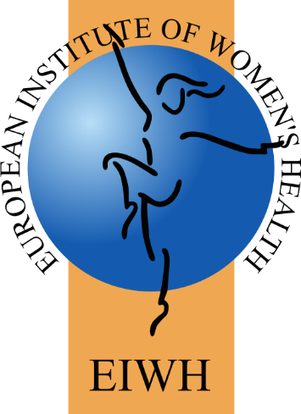

Invitation to Tender:

Public Website set-up and maintenance

European Institute of
Women’s Health

Tender title | Public Website set-up and maintenance
Tender description | To set up a public website for an EU-funded project and maintain it throughout the project, duration 5 years. Providing access to the website so the organisation responsible for the project can add publications, announcements etc, throughout the project. Project domain names have already been secured
Contract duration | 5 months initial contract to facilitate web design and set up
Application closing date | 4th April 2025
Submission details | Expressions of interest to be sent to the European Institute of Women’s Health (EIWH) at: hsiller@eurohealth.ie
Contact details | Informal questions may be directed to : hsiller@eurohealth.ie

- Background
1.1 European Institute of Women’s Health
Founded in 1996, the European Institute of Women’s Health (EIWH) is a non-governmental organisation (NGO) that uses an evidence-based to advocate for an equitable, sex and gender sensitive approach in health policy, research, promotion, treatment, and care. The Institute promotes biomedical and socio-economic research that addresses sex and gender-based differences to ensure access to quality treatment and care for women and their families across their lifespan. The EIWH strives to reduce inequities by drawing policy maker’s attention to the obstacles that women in minority, migrant, refugee and socio-economic disadvantaged groups face. The Institute’s activities work to empower individuals to play an active part in their own health management. The UN Sustainable Development Goals (SDGs) should be integrated into European health and well-being programming, policy, and practice. Concerted efforts should be devoted to promoting and achieving SDG 3 (good health and well-being) 5 (gender equality) and 10 (reducing inequalities) with a diverse group of relevant stakeholders. Europe can do more to follow suit and must make women’s health and equality a central focus.

Website requirements
- Provide a site that is functional and easy to use
- Ability to get an overview of what the project is about
Graphic Design
  - The site must comply with existing identity/branding and colour schemes where possible IF LOGO HAS BEEN DECIDED
  - We are happy to take advice and suggestion on how this might differ or be changed to improve the site and back up the other criteria specified.
Rounds of Changes allowed
  - Give details of the rounds of changes allowed
Maintenance, Training & Support
  - Please include in your quote the price for training our staff in using the website, onsite.

Copyright Issues
  - Ownership of assets including the content and imagery is in sole ownership of the EIWH
  - The system must be on an open source system
Reference Sites
- Please included reference sites of similar work
Company Information
  - Name of company, contact person, phone number, email
  - Place of business and postal address

Proposed Team
  - Provide details of each person who will work on this project – name, role, qualification and relevant experience.
Fee Structure
  - Design Costs
  - Commissioning or Start-up Costs
  - 3rd Party Costs Incurred
  - Ongoing support and maintenance cost per annum, applicable for the FIRST year
Decision Process
Timeframe
- It is anticipated that a contract will be awarded by the beginning of April with the contract to commence at the earliest opportunity following award. The set up of the website are to be completed by June 2025. Maintenance of the website runs throughout the project (until 2030)

2.1 Deliverable
The person or team is expected to design and set up a website, containing public and private areas, for an EU funded project on cervical cancer screening and vaccination. The website will consist of several areas which are accessible for the public, such as sections for, project objectives publications, news, progress of the project, and an internal section which is only accessible to the members of the project consortium. The successful contractor will ensure the website's security outlining in the tender how this will be achieved

The project leaders and the EIWH will need access to all sections to add/change content of the website.
The person or team is expected to include in the pricing the maintenance plan for the website until the project until its end, which is expected to be in 2030.

Application
3.1 Expression of interest
Suitably qualified and skilled professionals are invited to express their interest to undertake this work. Interested parties are asked to submit the following:
- A letter outlining their suitability and capacity to produce the website described in section 2.1. Please summarise your understanding of the requirements and of the relevant subject matter knowledge, making reference to relevant experience of having undertaken similar work previously.
- A full CV of the lead person must also be submitted, providing details of professional qualifications relevant to this project.

3.2 Submission procedure
Applicants should submit the required information outlined in Section 3.1 no later than 4th April COB to:
European Institute of Women’s Health email address Heidi Siller hsiller@eurohealth.ie
Applications received after the closing date will not be considered.
--ENDS--

