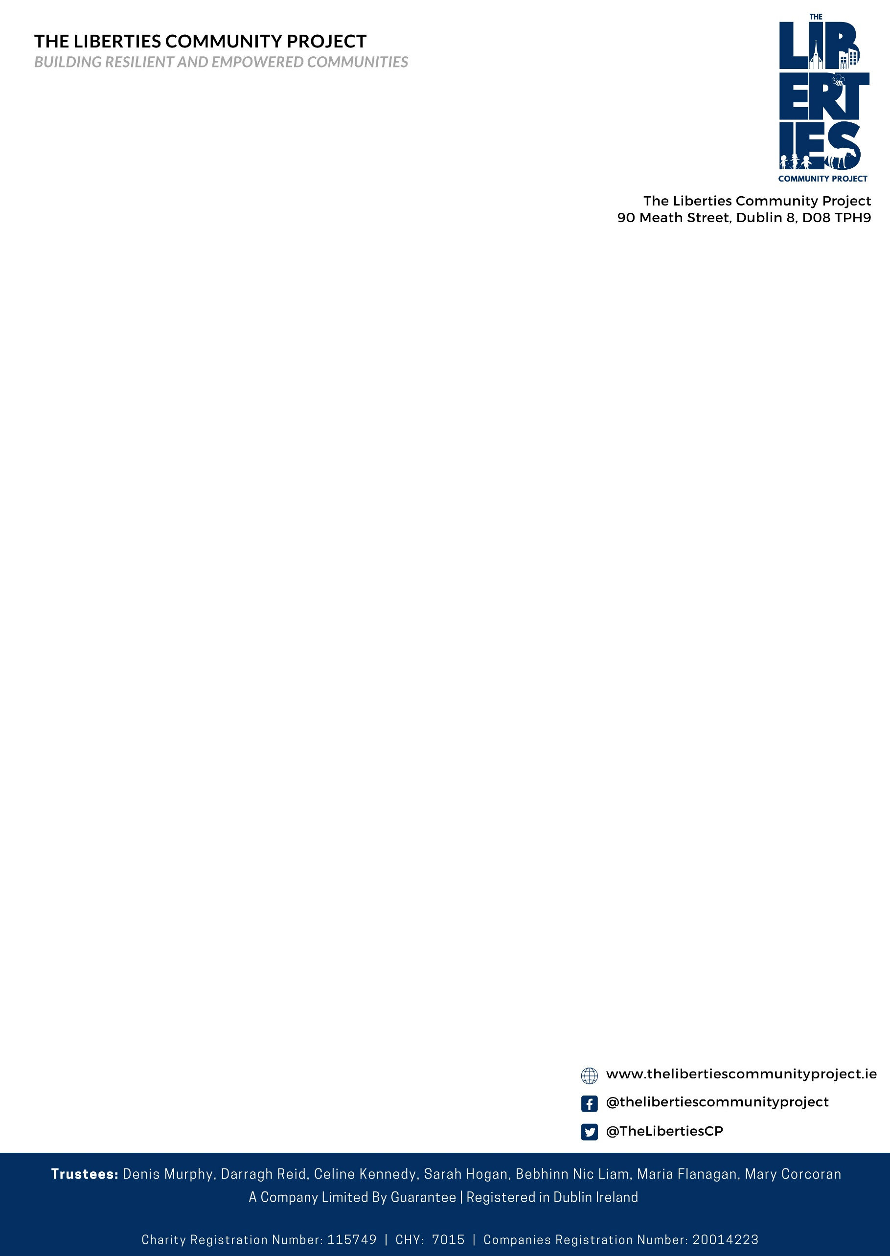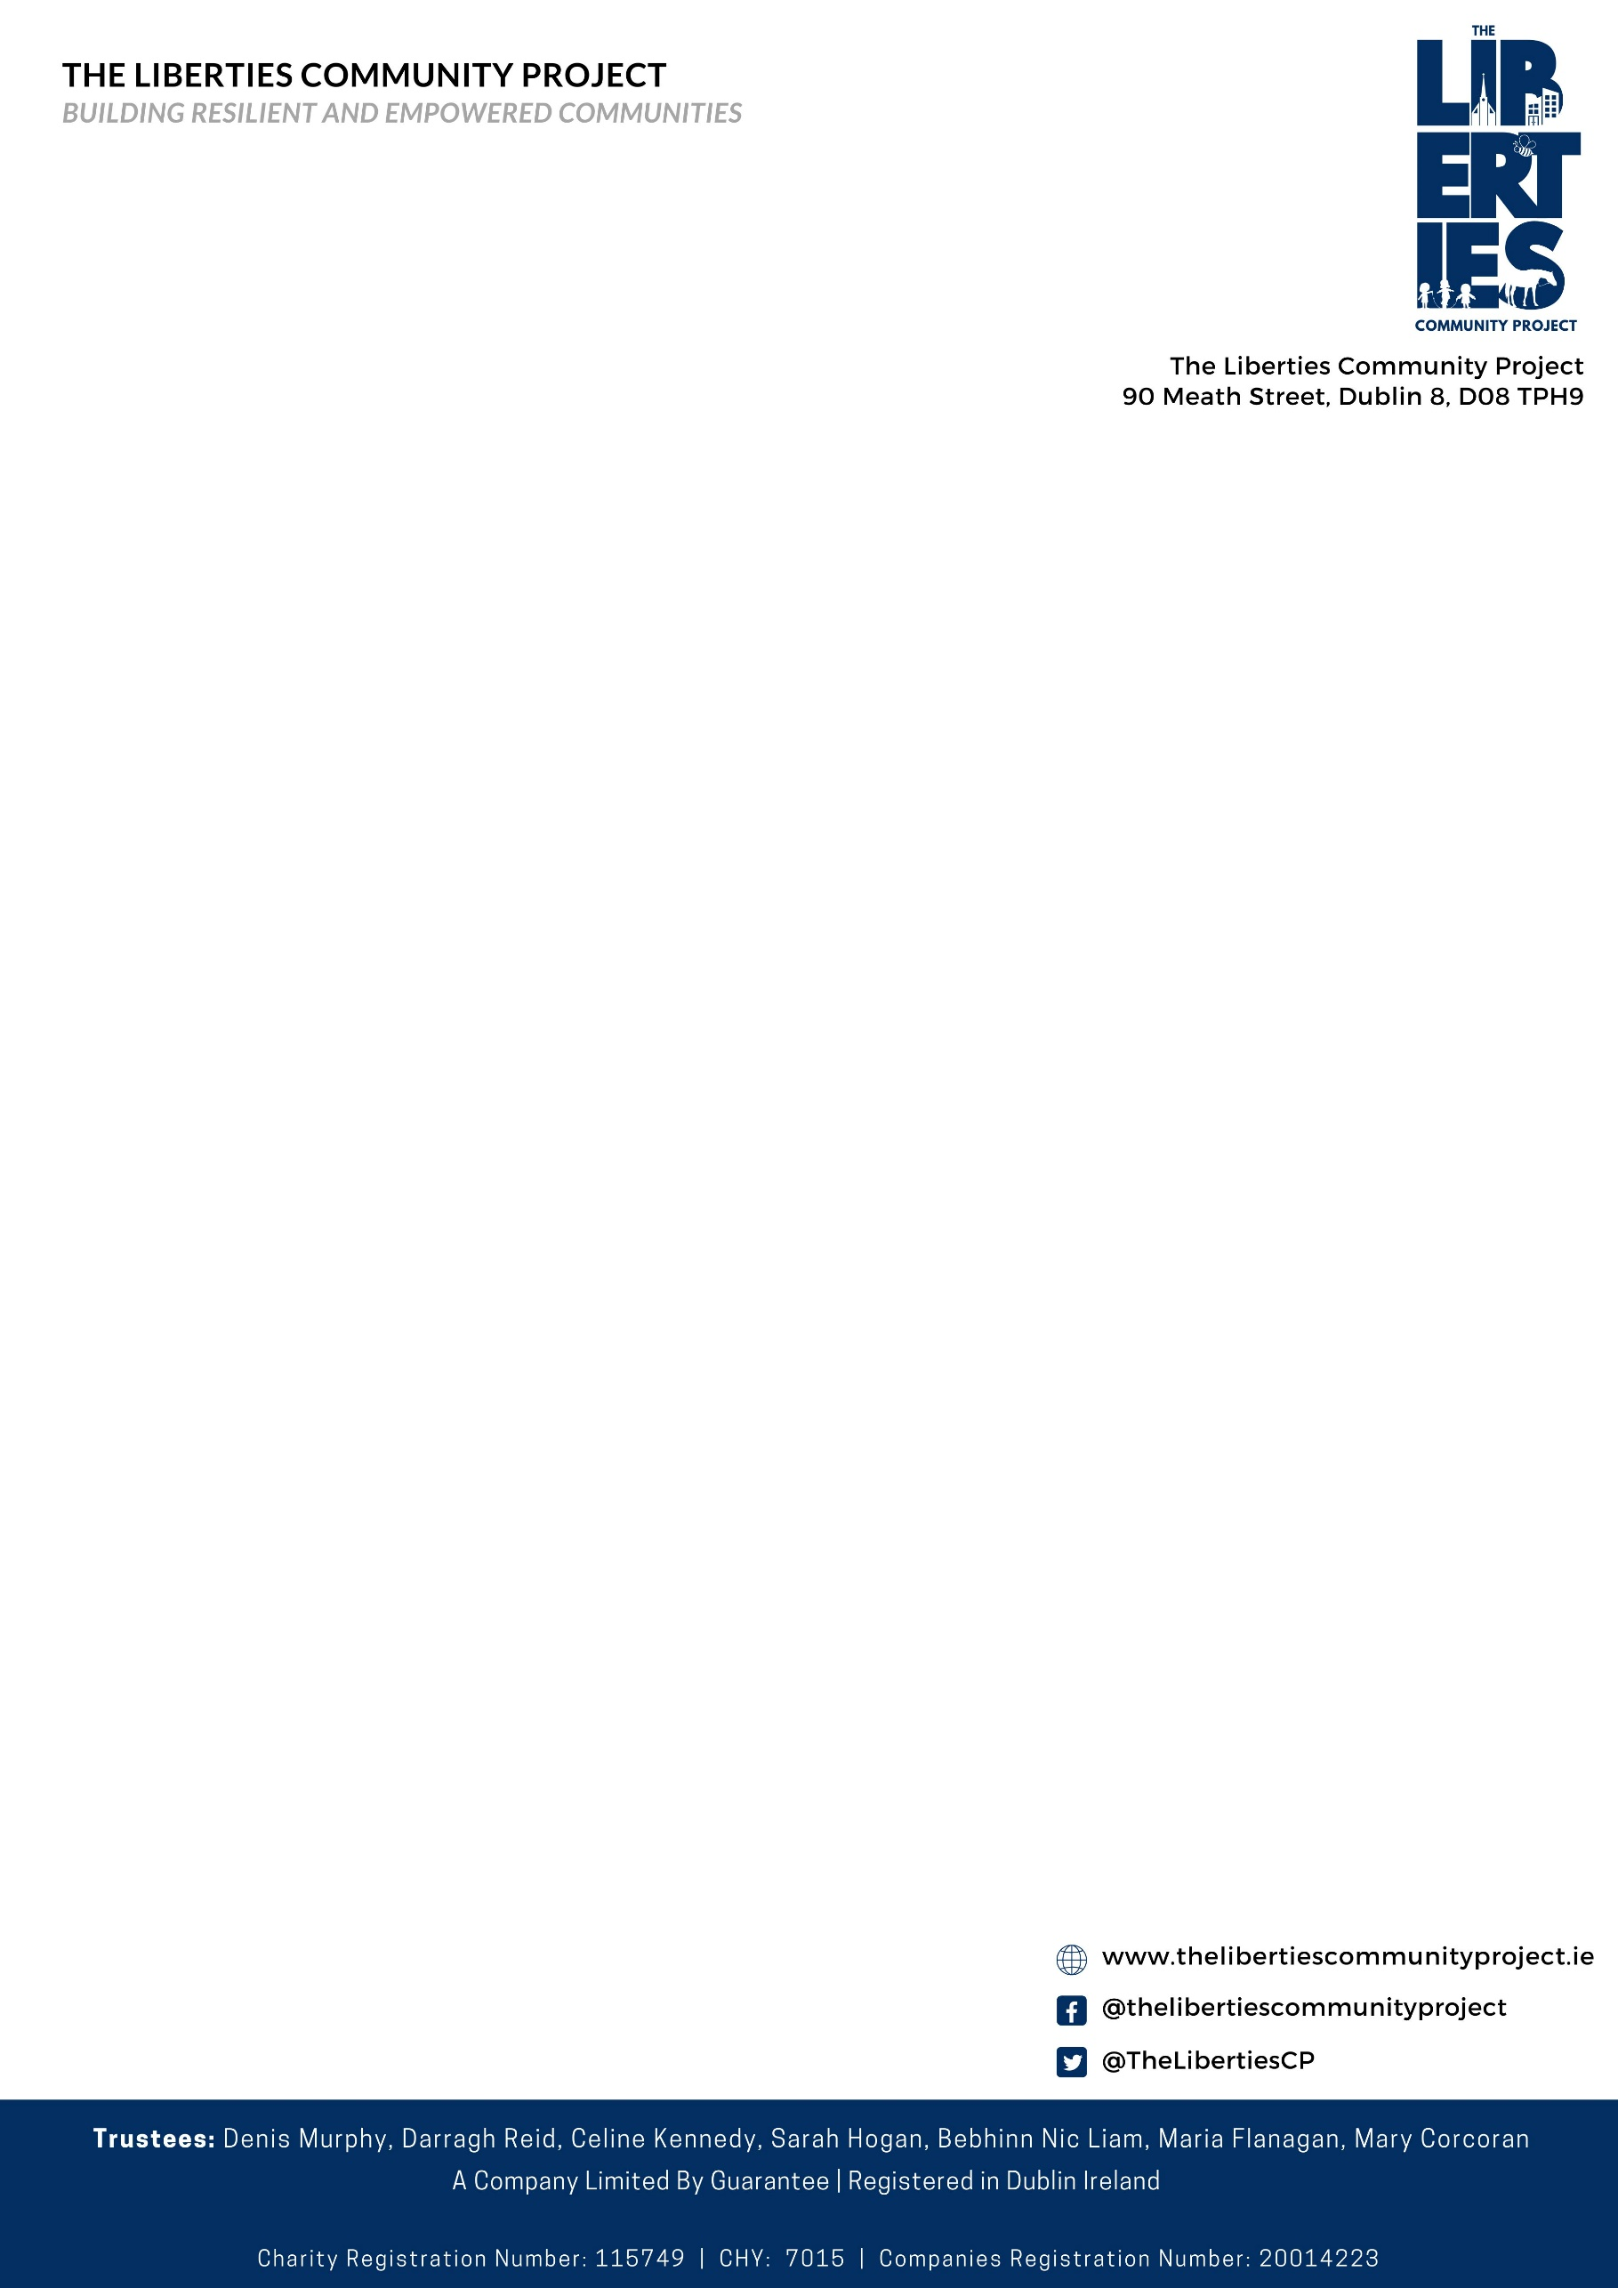

Job Description and Candidate Information

|  |  |
| --- | --- |
| **Post Title:** | **Smart D8 Community Coordinator** |
| **Post Status:** | **Specified Purpose Contract (Full-Time, 2 Years subject to successfully completing a probationary period of three months)** |
| **Location:** | **Based in 90 Meath Street, Dublin 8** |
| **Reports to:** | **CEO, The Liberties Community Project** |
| **Salary:** | **€44,000 per annum** |
| **Closing Date:** | **April 2nd 2025** |

**Overview**

The Smart D8 initiative has been successfully working with Dublin 8 residents, workers, students, healthcare providers, industry partners, start-ups and academic researchers to develop innovative solutions which could positively impact city life and the health and wellbeing of citizens in the decades to come.

The Smart Dublin 8 Partners are: The Digital Hub Development Agency, Dublin City Council, Smart Dublin, St. James’s Hospital, NCAD, St Patrick’s Mental Health Services, Tyndall Research Institute, TTMI-TCD, Health Innovation Hub Ireland, Health Services Executive Digital Academy and the Guinness Enterprise Centre.

Due to the success to date the Smart D8 initiative this role will provide the successful candidate an opportunity to build and galvanize participation of the Dublin 8 community in the development of health and wellbeing pilots and demonstration projects with real and lasting positive outcomes.

This job description describes the principal purpose and main elements of the job. It is a guide to the nature and key responsibilities of the job but is not intended as a wholly comprehensive or permanent description.

The Liberties Community Project is committed to a policy of equal opportunity.

**Hiring Body**

The Liberties Community Project- is an amalgamation of SICCDA and Robert Emmet CDP- two South West Inner City Dublin community development organisations established in 1982 and 2003 respectively in response to long term localised unemployment and poverty. A decision by both boards to engage in a voluntary merger process was affected in July 2024.

The Liberties Community Project deliver a wide array of charitable programmes across a number of key areas according to local need. However, we believe that effective community development is about more than delivering charitable services to ease the burden that inequitable policy and resourcing decisions have the on the South West Inner City community. It is about supporting a local community engage in research and advocacy projects that can drive decisions that affect their own development; and it’s about enjoying the journey and the learning that comes with this.

**Key Responsibilities**

The area of health and wellbeing in cities is one that is garnering more and more attention as developments in technology allow us cheaper and more accurate ways of managing both human and environmental systems. In addition to this, there is an increasing body of research regarding the relationship between human health and our urban environment, particularly in the areas of air quality, noise pollution and green and blue space within cities. At the same time, we are faced with multiple challenges in the health system including an ageing population, high rates of obesity and increasing antibiotic resistance, challenges which will require inter-disciplinary and cross-organisational cooperation to tackle.

The Smart D8 initiative aims to develop ongoing collaborations and unlock new opportunities for innovators in the areas of healthcare and community wellbeing in Dublin 8.

The successful candidate will report to the CEO of The Liberties Community Project and will work alongside the Smart D8 partners to coordinate activities over the next two years aimed at driving pilots of Smart Health and Wellbeing in Dublin 8**.**

The role will support Smart D8 partners to:

* Provide a trusted interface into the Dublin 8 population
  + Develop and document contacts and relationship with local communities
  + Develop and document contacts and relationship with local enterprises
  + Represent and present Smart D8 and its initiatives at meeting and events involving the Dublin 8 population
* Foster opportunities for collaboration between Smart D8 and the Dublin 8 population
  + Develop and document knowledge of relevant expertise in the local population
  + Develop and manage relationships leading to joint projects involving the local population
  + Support the annual Smart D8 call for pilots activities from an end user perspective
  + Develop and manage a repository of local population contacts who may contribute or participate in pilot activities
* Support the development of funding proposals
  + Develop and manage content relevant to presentation and proposals focused on Enterprise, Research and Government audiences
* Support Smart D8 good governance
  + Assist in the preparation, attend and present at Smart D8 partner meetings
  + Document activities and measure impacts for all relevant Smart D8 actions
  + Be available to assist the Smart D8 Programme Manager and Chair
  + Support Smart D8 events
  + Support content for Smart D8 web and social media channels

The ideal candidate will have previous experience in the management of diverse stakeholder groups including the residential and business communities, public bodies, academic institutions and multinational and small/medium companies. Knowledge of population health and wellbeing would be a distinct advantage.

**Standard duties and Responsibilities of the Post**

* Responsibility for the operational project management of community collaborations;
* Engaging the local population to participate in Smart D8 activities and capturing data to benchmarking impacts;
* Responsibility for the coordination, planning and implementation of project workshops, events and meetings including events to promote innovation in the area of population health and wellbeing;
* Monitoring, collection and timely reporting of project outputs, milestones and deliverables to the Management team and associated co-funding agencies;
* Coordinating stakeholders in Dublin 8 to advance the smart D8 pilots;
* Attending and demonstrating progress at showcase events and where necessary preparing materials for showcasing;
* Enabling additional funding opportunities for the Smart D8 initiative.

**Person Specification/Qualifications**

* Candidates must have a Bachelor’s degree (a Masters would be advantageous) in an area related to health and wellbeing, project management, application of technology, public health, environmental science, economic development, or computer science.
* Any combination of the above disciplines would be very favourable.

**Essential Knowledge & Experience:**

* Proven experience of managing internal and external community partner relationships on behalf of an organization, including evidence of being the key contact point, developing key relationships to enable project delivery;
* Strong Project Management Skills with at least 2 years’ experience working in inter-disciplinary teams;
* Facilitation and workshop design skills, with emphasis on presenting and engaging diverse audience.
* Previous experience and the ability to demonstrate the use of Project Management methodologies and structures is desirable;

**Desirable Knowledge and Experience:**

* Experience or strong interest in or knowledge of the population health and wellbeing ecosystem in Ireland and abroad and of the key organisations, statutory bodies and companies involved in this field;
* Previous experience in preparing funding applications and a practical understanding of national, European funding schemes.
* The ideal candidate will have demonstrated experience of working in a multi-faceted team environment. S/he will work well under pressure and have the ability to work on his/her own initiative.

**Skills and Competencies:**

* S/he will have excellent, interpersonal, communication and presentation skills – both written and verbal;
* S/he will be an effective and persuasive communicator with the ability to influence in a positive way and strong negotiation skills;
* Resourceful / conscientious and self-motivated individual with a ‘can do attitude’ – ability to see tasks through to completion (essential);
* Excellent analytical skills - can identify a problem/risk and propose solutions to multi-faceted problems (essential);
* Excellent time management skills and highly organized. The ability to meet deadlines while working on multiple projects simultaneously, to priorities tasks and see through to completion (essential);
* Flexible approach – available to work outside normal hours are required on an occasional basis (essential);
* Excellent IT skills including experience with MS Excel, Word, PowerPoint, Outlook and Google Business Suite.

**Application Information**

In order to assist the selection process, candidates should submit a Curriculum Vitae and a Cover Letter that specifically address the following points in their application:

* Please detail how your experience and skills meet the above requirements;
* Give examples of your involvement in managing complex customer relationships involving multiple stakeholders on behalf of the organization;
* Illustrate, through past examples, the ability to work on your own initiative and resolve problems, deliver results and impact;
* Relevant knowledge or experience related to smart cities, connected health and/or community wellbeing projects.

In addition, we would like to get an overview of the experience you have gained of leading or playing a significant role in projects and would ask you to complete the following table and include it alongside your cover letter.

|  |  |  |  |
| --- | --- | --- | --- |
| **Summary of Key Project Experience** | | | |
| Bullet point summary of relevant project experience from your career to date | | | |
| *Project* | *Role* | *Duration* | Stakeholders |
|  |  |  |  |
| **Picking one significant project, provide a brief overview of the project and its aims. What was your role and reporting requirements? Give a concise summary of the stakeholders, the milestones, resources deployed and the challenges along the way? (up to 300 words)** | | | |
|  | | | |
| **Please outline any experience you have in working with communities with a focus on health and wellbeing.** | | | |
|  | | | |

The information contained within the cover letter, curriculum vitae and table above should be sent by email to info@thelibertiescommunityproject.ie before 5pm April 2nd 2025. It will be used to develop a short list of candidates who will be invited to interview.

Candidates should note that the interview process for this appointment may include the delivery of a presentation.