**CITIZENS INFORMATION SERVICE**

**Administrator**

**Part time Permanent Position**

Applicant Information Pack

**March 2025**

**Administrator - Contents**

Citizens Information Service Offer- **Page 3**

CIS Locations - **Page 4**

Administrator Role - Job Description - **Page 5**

Person Specification- **Page 6**

Required Competencies – **Page 7**

Terms and Conditions - **Page 8**

How to Apply **- Page 9**

**Citizens Information Service - Service Offer**

Citizens Information Services (CISs) provide free, impartial and confidential information, advice and advocacy services to the public. Each Citizens Information Service covers a geographical area within their region, facilitating both rural and urban areas, delivering a service through a network of Citizen Information Centres (CICs).

**Information and Advice**

Our Information Officers assist people with queries in relation to a broad spectrum of public and social services, including social welfare entitlements, income tax calculations, housing supports and access to health services. Our staff receive regular training and social policy updates to ensure that the information and advice that we provide is up-to-date and relevant for CIS service-users.

**Social Policy**

Our staff also engage in social policy reporting, highlighting issues that affect our clients in accessing public services, which in turn feeds into the work of the Citizens Information Board in the development of policy papers and recommendations to government. Through this process, CIS Information Officers capture social policy issues in real-time, facilitating the development of responsive and evidence-based policy reporting.

**Advocacy**

When required, Information Officers can provide further support through our advocacy service. This can mean assisting someone to write a letter or make a phone call, or a more complex and longer-term process such as preparing people for, or representing them at, a Social Welfare Appeals Office or Workplace Relations Commission hearing. All Information Officers are supported by a regional Advocacy Support Worker who provides expert advice, coaching and mentoring in this key aspect of our work.

The range and level of advocacy support provided by CISs has continued to develop and expand year on year, with significant outcomes achieved for people around the country in the areas including employment, equality, housing and social welfare.

**Citizens Information Services – Locations**

Each Citizens Information Regional Company covers a geographical region, facilitating both rural and urban areas, delivering a service through a network of Citizen Information Centres.

The 8 regional CIS companies cover the following areas: North Dublin, Dublin South, North Connacht & Ulster, North Leinster, North Munster, South Connacht, South Leinster and South Munster, as illustrated in the map below. Each CIS Region is subdivided into a number of CIS Service Areas which in turn each contain a number of Citizens Information Centres.

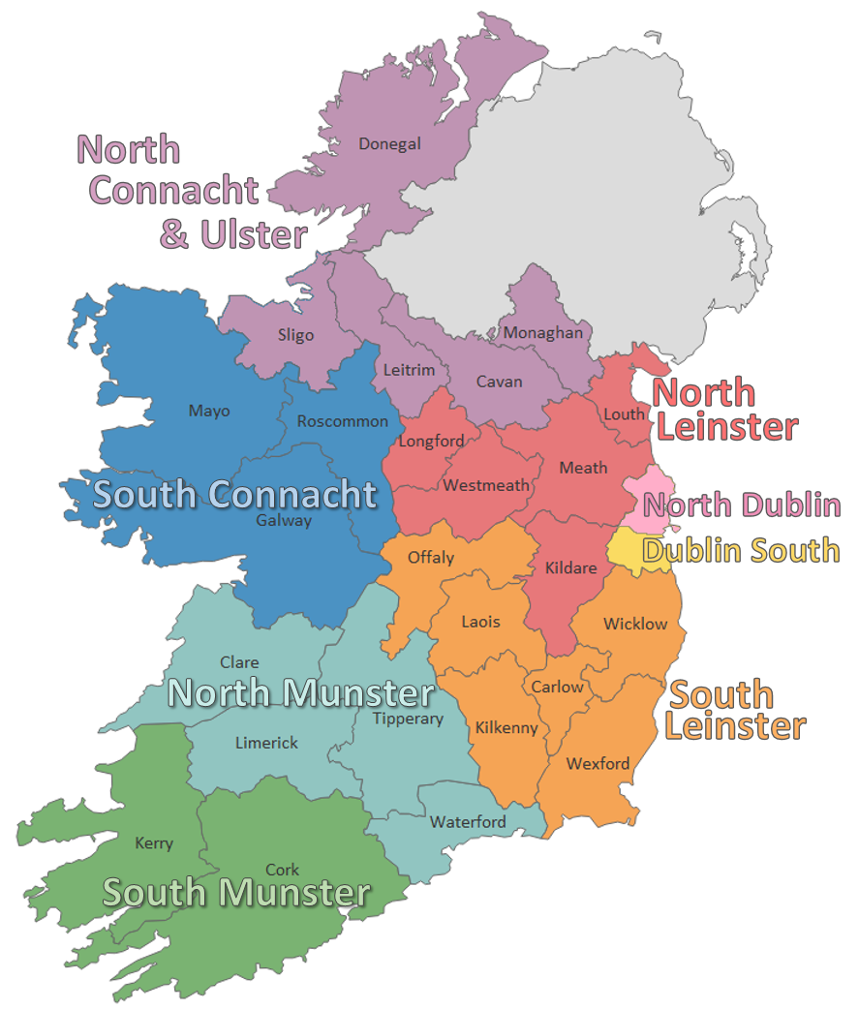

**Administrator - Job Description**

**Purpose of the job**

The Administrator will support the North Dublin Citizens Information Service Development Manager based in Dublin City Centre in the delivery of a high quality service across a nominated area.

**Reporting to**

The Development Manager

**Main Duties**

* The Administrator is responsible for clerical and administration duties to support the Development Manager and regional management team in a wide range of activities.

**Service Delivery Administration:**

* Support the service delivery management team administratively in the work of the Citizen Information Service by;
* Carrying out typing duties and maintaining records/files such as centre case files, local HR files, company files etc. as directed by the Development Manager
* Arranging events and meetings and taking minutes at such meetings as directed by the Development Manager
* Respond to, and allocate to the appropriate staff members as required, relevant telephone, letter, email and personal enquires in a prompt and professional manner. This may include overseeing reception, queues and/or appointment calendars as required.
* Ensure that the day-today administration of the Centre is carried out in a professional manner
* Provide administrative support to Information Officers, other staff and volunteers as directed by Development Manager

**Facilities Administration:**

* Stock taking and ordering of office supplies in line with company guidelines
* Ensure the service area has an adequate stock of the publications, information leaflets, application forms etc.
* Support the Development Manager in all matters related to premises management

**Financial Administration**

* Assist with financial monitoring, using a cloud based system to upload purchase orders and invoices etc., in line with financial guidelines, in liaison with the Regional Administrator as required
* Prepare and assist in the collation and collection of data for inclusion in reports as directed by the Development Manager.

**General Administration**

* Support the Development Manager in meeting all health and safety requirements as set out in the Health and Safety Statement
* Support local tasks such as rosters / maintaining leave requests as directed by the Development Manager
* Support regional projects/functions/events as directed by the Development Manager
* Attend seminars/meetings as directed by the Development Manager
* Perform other duties appropriate to the role which may be required and agreed with the Development Manager from time to time
* This is not an exhaustive list but serves to reflect the nature of the duties included in the role. Given the nature of the organisation, the role is subject to change over time
* The job may involve on occasion working unsocial hours (evenings and weekends). Time off in lieu may be taken by agreement with the Development Manager.

**Administrator - Person Specification**

**Essential Educational Qualifications and Attainments**

* Hold a recognised qualification at a minimum of Level 5 on the National Framework of Qualifications.
* A minimum of 2 year’s Administrative experience.

**Desirable Educational Qualifications and Attainments**

* An NFQ recognised qualification in financial administration and / or office administration

**Essential Knowledge, Skills & Experience**

* Experience of working in an administrative role in a busy office environment and excellent customer service
* Excellent written, communication and numeracy skills
* Extensive IT skills and excellent working knowledge of Microsoft Office
* Experience in data processing and filing using ICT systems

**Desirable Knowledge, Skills & Experience**

* Knowledge of the Citizens Information Services and the work they do
* Knowledge of / experience in the following areas:

- Payroll

- IT financial software packages for example, Thrive.

- HR software package

- Financial and accounts data processing

- Dealing with members of the public

**Core and special aptitudes, and skills**

* Ability to work on own initiative or as part of a team
* Strong organisational skills and attention to detail
* Excellent interpersonal skills, self-motivated, flexible and reliable

**Administrator – Required Competencies**

|  |  |
| --- | --- |
| **Competency** | **Definition** |
| **Information processing and records management** | Records and retrieves information electronically and in hard copy.  Uses and supports data collection and case management systems.  Observes confidentiality in the administration of personal and financial data. |
| **Communication** | Fluent in written and verbal English.  Writes clearly and concisely producing accurate emails, letters and documents.  Keeps clear records that are easy for others to understand. |
| **Customer Service** | Demonstrates a commitment to quality customer service and displays a client centred approach to their work.  Engages with others in a respectful and understanding manner. Shows cross cultural sensitivity. |
| **Office Accounts** | Shows attention to detail in the processing of information.  Processes numerical information efficiently. |
| **Team Working** | Works effectively as part of a team.  Demonstrates an openness to support, supervision and feedback and adapts approach in a constructive manner |

**Administrator – Terms and Conditions**

This is a permanent part time position, subject to satisfactory completion of a six-month probationary period. The period of probation may be extended at the discretion of the Development Manager.

The successful candidate will be available to work 17.5 hours per week (part time). There may be a requirement to work evenings from time-to-time.

**Salary: Full Time Salary:** Scale range of €26,411, €27,652, €28,889, €30,132, €31,372, €32,611, €33,848, €35,082, €36,323 (max), €37,560 (LSI1), €38,803 (LSI2). [Pro rata for part-time staff]

**Incremental Credit:** It is expected that all new entrants to North Dublin Citizens Information Service will be appointed at point one of the salary scale. However, the company operates an incremental credit process for appointments higher than point one. This process is applicable to new entrants into Citizens Information Service. Incremental credit criteria, based on the competencies for the role, are assessed against employment history as laid out in the application form only. A request for incremental credit from a successful candidate must be made within the first 3 months of employment. The decision on whether to award an incremental credit or not is a decision made by the Board and is subject to the availability of funding.

**Pensio** **Pension:** A company pension scheme is in place, and membership is obligatory upon commencement. Employee contribution; 5% of salary, Employer contribution; 7% of salary. Please note the Citizens Information Service has established a normal retirement age in line with the state pension age (currently 66).

**Annual Leave:** Calculated on a pro rata basis for part year service as follows:

23 days

24 days after 2 years’ service

25 days after 5 years’ service

Full terms and conditions are contained in a Staff Handbook, which is issued with and forms part of the Employee Contract.

**Administrator – How to Apply**

* A relevant application form can be accessed at [www.citizensinformationboard.ie](http://www.citizensinformationboard.ie)
* Applicants must possess all required competencies for the role and will be shortlisted solely on the basis of information provided in their completed application form.
* Curriculum Vitae (CVs), late, incomplete or hand-written applications ***will not*** be considered.
* **Closing date:** 28th March 2025 @ 3pm
* **Please email application form to:** [Teresa.gill@citinfo.ie](mailto:Teresa.gill@citinfo.ie) with the subject header Administrator vacancy
* Please note that shortlisting will apply and canvassing will disqualify.
* If you require any reasonable accommodation to your application due to your circumstances (e.g. disability), please contact the above email address and we will try and facilitate you where reasonably practicable.
* Successful applicants will be required to complete a skills assessment (Word and Excel) on the day of interview.
* A panel of qualified candidates may be formed from which permanent, part-time Administrator posts which arise in a specified period, up to a maximum of 12 months, will be filled. Post applied for will be located in the **North Dublin** region.
* For information on how your personal data will be used as part of this process please refer to our Data Protection Notice for Job Applicants, available at the following link:

<http://www.citizensinformationboard.ie/en/data_protection/cis.html>

***Citizens Information Services are equal opportunities employers.***