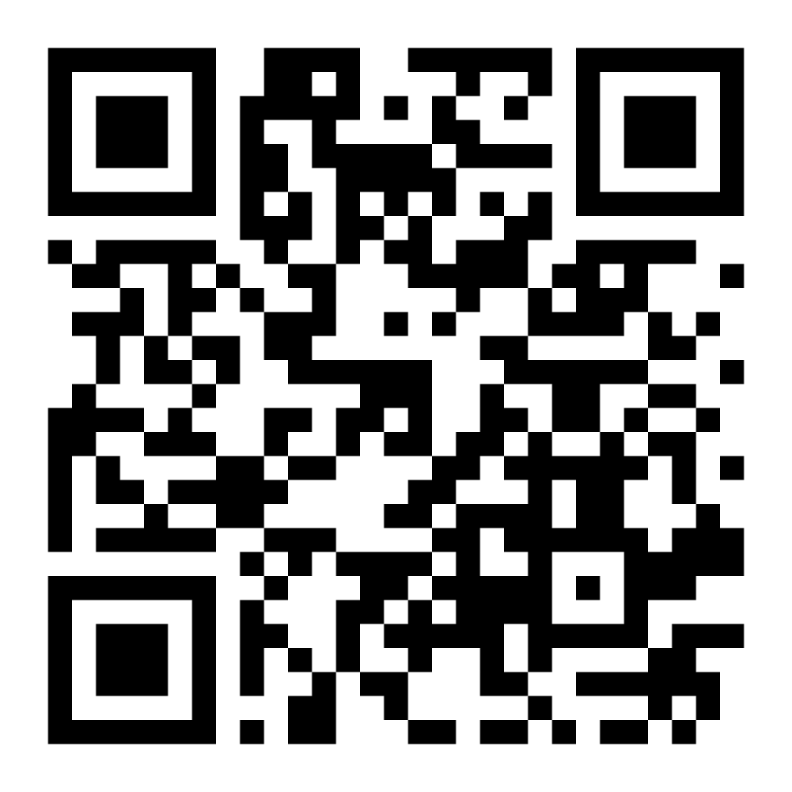

**To apply, please scan the QR code or click the link** <https://form.jotform.com/250644297102352>

For more information you can WhatsApp Erica on

**086-8013752**