Description: :::::Desktop:Screen Shot 2013-12-18 at 13.18.38.png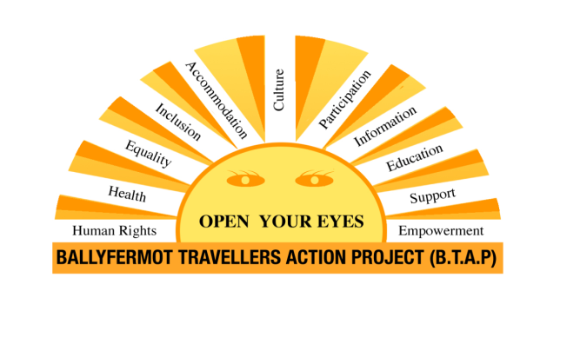

**Job Specification**

|  |  |
| --- | --- |
| **Job Title** | Tusla Traveller Parent Support Project  Family Link Worker |
| **Opening date for Applications** | 12th March 2025 |
| **Closing Date for Applications** | 5pm 28th March 2025 |
| **Proposed Interview date(s)** | Week commencing 7th April 2025 |
| **Contact for Informal Enquiries** | Shay L’Estrange  0876412557  shaybtap@gmail.com |
| **Location of Post** | Ballyfermot Family Resource Centre, Lynches Lane Ballyfermot, Dublin 10 |
| **Details of Initiative** | Tusla, The Child and Family Agency have committed to working together with the Traveller communities to implement a Traveller Parent Support Programme to support parents from the Traveller Community to become trained facilitators in a culturally adapted Parents Plus Early Years programmes, and to encourage attendance at these Programmes.  This initiative has been supported by the Department for Children, Equality, Disability and Youth through specific funding to Tusla across 11 areas.  A Family Link Worker post will work in each of the 11 areas, working between 20 – 35 hours per week. It is envisaged the worker will be employed by a local Traveller or other community-based organisation.  A local advisory group, including representation from the Traveller organisation, PPFS and other relevant stakeholders will liaise with the National Implementation Advisory group in the planning and implementation of this initiative (This may be an existing group, or a group established for the purposes of supporting this pilot)  Induction training will be provided to the successful candidate, and each Family Link Worker will be trained in Parents Plus Early Years programme and other early intervention programmes, determined by local parenting support infrastructure. |
| **Scope and Purpose of the Post** | The Family Link Worker will have key responsibility in the areas of relationship building between the local Traveller community, Tusla Prevention Partnership and Family Support, HSE and relevant local community partners who support parents and families.  The Family Link Worker, together with the Traveller organization and PPFS staff will identify parents' support needs and will contribute to the areas parent support plan if available, in conjunction with key partners, through training as Facilitator Parents Plus and other Early Intervention programmes and co-delivery of these programmes. Here there will be a particular emphases on 0-6 year olds.  The Family Link Worker will also engage and be fully supported in the national work across the areas, in adapting and developing the established Parents Plus Programme to ensure they are culture-proofed and more accessible to the Traveller community. This work will be conducted in partnership with Traveller organizations and the Parents Plus Charity.  **Applications are particularly welcome / sought from members of the Traveller community as this is essential to the purpose, and ethos of the pilot.** |
| **Duties and Responsibilities** | 1. Develop and maintain strong working relationships with the Local Traveller community. 2. Develop and support strong working relationships with and between the local Traveller parents, Traveller organization, TUSLA, HSE and the various community organizations as appropriate. 3. To collaborate with Traveller parents and families to document and collate Traveller experiences with mainstream services with a view to supporting mainstream services to be more available in culturally appropriate ways to Traveller needs. 4. To train as a Facilitator in the Parents Plus Early Years Programme and other appropriate early intervention supports. 5. To co-deliver Parents Plus programmes. 6. Working with and influencing parents within the local communities to engage in parenting/family support programmes as required as well as with education partners to work in partnership to support children reaching their potential. 7. Promote and represent the work of the pilot to local organizations. 8. Undertake tasks agreed by the employing agency and agreed by the local implementation / advisory team appropriate to the skills of the Family Worker. 9. Focus primarily on the work of the early intervention supports. (There may be times where other support needs will need to be addressed) 10. Supporting BTAP Education team to achieve the best outcomes for Traveller children in the education system. 11. Support BTAP ABC Family Development Worker in delivering on targets.   **The above Job Description is not intended to be a comprehensive list of all duties involved and consequently, the post holder may be required to perform other duties as appropriate to the post which may be assigned to him/her from time to time and to contribute to the development of the post while in office.**  The successful candidate will undertake on the job training/continuous professional development to carry out their duties effectively. |
| **Qualifications and / or Experience** | Applicants will by the closing date of application have the following:  Essential   * An understanding of how to support Traveller Communities in culturally appropriate ways. * Experience paid or voluntary, in supporting the Traveller Community. * A good knowledge of family support and community development. * A general knowledge of computers and communication technology. * Experience of working as part of a team. * Demonstrate good communication skills. * Demonstrate good leadership skills. * Demonstrate an ability to promote an understanding of Traveller Parenting experience within the partner agencies.   Desirable   * A third level qualification in a related field, e.g. social care, youth work, community development work etc.   **Character**  Each candidate and any person holding the office must be of good character.  The candidate must be at least 18 years of age. No upper age limit shall apply. |
| **Skills, competencies and/or knowledge** | * Strong communication and interpersonal skills including influencing and negotiation skills. * Ability to work with other staff as part of a team and build relations both within the team and outside of the organisation. * Previous relevant work experience, in a paid or voluntary capacity. * Ability to work on own, plan work, and complete tasks. * Ability to identify challenges and be willing to problem solve. * Ability to manage timekeeping, meet deadlines and commit to being a reliable member of a team. * Commitment to the provision of a quality service and bringing about better outcomes for Traveller children and families. * Understanding of issues impacting on the Traveller community and to help others understand these, including the ability to identify and challenge discrimination and racism. * Strong skills around confidentiality and the ability to manage confidential information appropriately is essential. * Ability to take the lead on projects including team leadership skills. |
| **Other requirements of the role** | To complete Garda Vetting. |
| **Campaign Specific Selection Process**  **Shortlisting / Interview** | Short listing may be carried out on the basis of information supplied in the CV and cover letter. The eligibility criteria for short listing are based on the requirements of the post as outlined in sections of this job description under “Qualifications and/or Experience” and “Skills, competencies and/or knowledge”.  Failure to include information regarding these requirements may result in candidates not being called forward to the next stage of the selection process.  Those successful at the shortlisting stage of this process will be called forward to interview. |
| **Application Process** | Please send CV and cover letter, marked for the attention of  Shay L’Estrange Ballyfermot Travellers Action project, Ballyfermot Resource centre, Lynches Lane Ballyfermot Road, Dublin 10, phone 01 6264166, 0876412557 .  Email: shaybtap@gmail.com  Closing date for fully completed applications will be Friday 28th March 2025 at 5.00pm. No late applications will be accepted. Canvassing will lead to disqualification. |