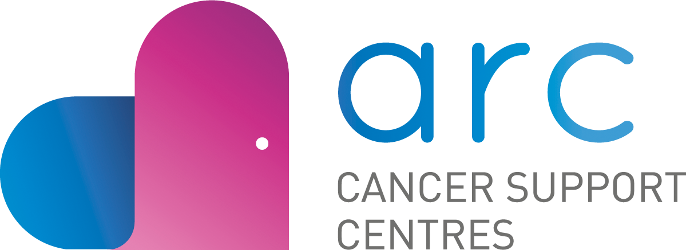

Reflexologist Volunteer Application
Personal Details
Name
Address
Phone Number
E-mail

Availability (please tick all that apply)
Monday  AM PM |  | Tuesday  AM PM |  |  | Wednesday  AM PM |  | Thursday  AM PM |  | Friday  AM PM
Location
65 Eccles Street |  |  |  |  |  | Lowell House, 23 Herbert Avenue
Skills or Experience Related to the Role
Recognised Reflexology Qualification | Yes / No
Completed Reflexology in Cancer Care Course | Yes / No
Please tell us a little about your experience, skills and knowledge:
What interests you about volunteering with ARC?

References
Please give us the name of two references (whom you have known for at least 2 years and who are not family members or friends).

Name (1)
Address
Mobile Phone
E-Mail Address
How does this person know you?

Name (2)
Address
Mobile Phone
E-Mail Address
How does this person know you?

Agreement and Signature
By submitting this application, I affirm that the facts set forth in it are true and complete.
Name (printed)
Signature
Date

Please be advised ARC is required to complete Garda Vetting process on all successful applicants.

ARC is also required to request that suitable applicants complete and provide certification of completion in
- Children First Training
- Safeguarding Vulnerable Adults Training
We will provide support and guidance around each of these requirements.

