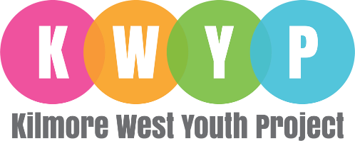
Position Title: | Youth Justice Worker
Location: | Belmayne - Unit 1B, Churchwell Gardens, Belmayne, Dublin 13, D13 XTK5
Hours of work: | 35hrs per week
Salary: | In line with CDYS Youth Worker scale

Role Description | To divert young people who have been involved in anti-social and/or criminal behaviour, by providing suitable interventions, activities and programmes to facilitate personal development, promote civic responsibility and improve long-term employability prospects.
Key Duties
- Developing positive relationships with young people.
- Planning, developing, delivering, and evaluating educational responses to issues such as drug abuse, youth homelessness, racism, bullying, equality, early school leaving, health education etc.
- In conjunction with the Line Manager, review and plan for new referrals including completion of initial assessment of participant.
- Create appropriate needs led plans e.g. support plans, risk management plans.
- Facilitate and participate in all aspects of planned interventions with participants (e.g. group work, overnight respite, individual work & activities).
- Providing a service to these young people at times and locations that work for them, including regular street work services on evenings and weekends.
- Reporting to the Youth Diversion Manager and responsible for ensuring the development and implementation of the Youth Justice Strategy 2021 – 2027.
- Commitment to the purpose of KWYP and work within values, policies and procedures of the organisation and in the context of current legislation and regulations.
- Attending meetings as required - team meetings, subcommittee meetings, whole organization, interagency work etc.
- To report any area of concern to your Line Manager in a timely fashion.
- Documenting and recording the work using the agreed systems.
- Assisting in the preparation of various reports for funders, and others.
- Observing all Kilmore West Youth Project policies and procedures, including child safeguarding and health and safety.
- Working with other agencies in the community that are relevant to our work with the target group young people e.g. local education service providers, drug services, youth projects, local community projects/services, DCC, an Garda Siochana, etc.
- Participating in training related to the role as required.
- Participating in regular team meetings and ensuring good quality communication on the team is maintained.
- Participating in regular supervision sessions and staff appraisals.
- Advocating on behalf of young people where appropriate.
- Participate in relevant in-service training as agreed by the Line Manager.
- Reporting any Child Protection issues as a Mandated Person.
Skills and Experience
Qualifications | A professional qualification in Youth and Community Work is essential plus two years’ experience working with young people ‘at risk’ is desirable.  Or  An equivalent professional qualification or relevant degree plus two years full time experience working with young people ‘at risk’ in a youth work setting is essential.  Or  Non-Academic qualification: Must have worked within paid employment as a full-time youth worker without formal qualifications for at least 3 years.
Desirable | Full clean driver’s license
Personal Characteristics | - Ability to build and maintain effective relationships with young people  - Interest in personal and professional development  - Ability to reflect on situations  - Open and honest  - Self-motivated, enthusiastic and passionate about working with young people  - Kind, caring and empathetic  - Creative and flexible to the needs of the young people, community, team and organisation

Additional information:

The candidate must be flexible in this position and must be prepared to carry out all lawful instructions as may be given to them by the management from time to time.

Candidates under consideration for employment in KWYP will be subject to Garda vetting.

